

student How-to

OC Performance Scheduling

Oklahoma Christian University

Table of Contents

1. Login Steps 2

a. Login 2

b. First Time User or in the Semester 4

2. Event Signups 7

a. Sign up for a Time Slot 7

I. Individual Signups 10

II. Group Signups 12

b. Request Time Slot 13

c. Request Additional Time Slots 15

d. Request Availability 16

e. Edit Signup 17

f. Delete Signup 18

3. Performances 19

4. Instruments 22

5. Repertoire 26

6. Logout 31

# Login Steps

## Login

* Navigate to the [Performance Scheduling website](https://performance.oc.edu/) (click on this link that goes to <https://performance.oc.edu/>).
* We use Google to authenticate our logging in.
* You must use your OC affiliated email address to login.
  1. Click Sign up with Google.

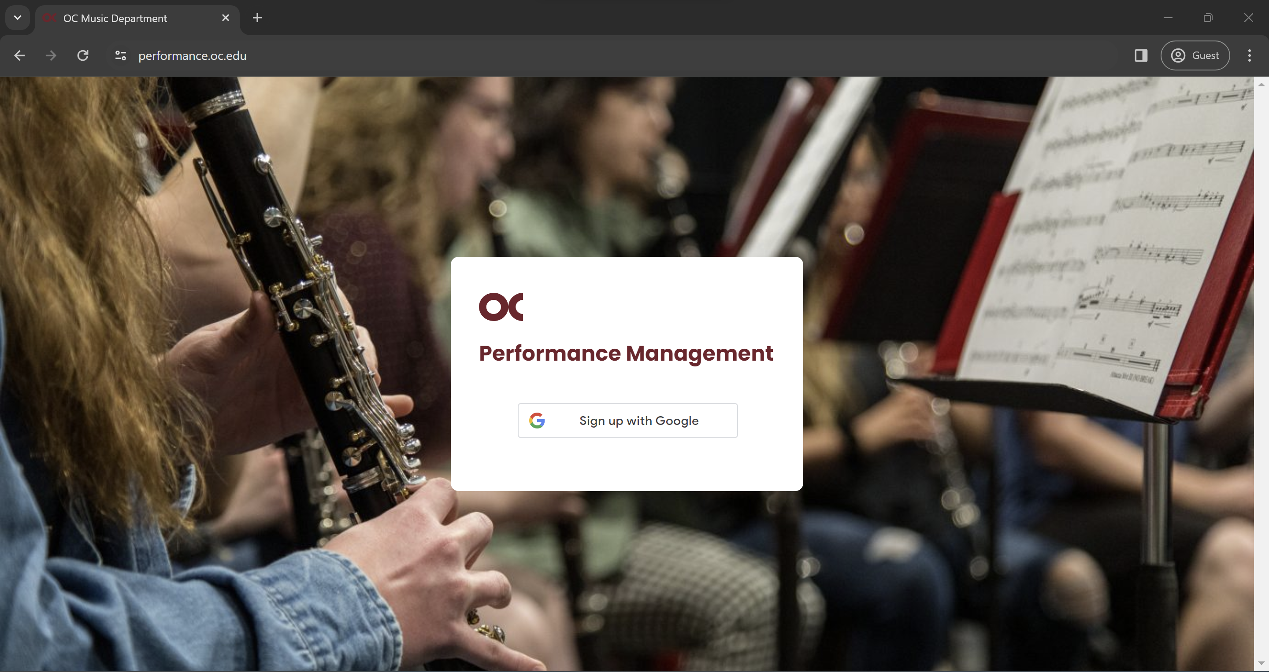

* 1. Enter your **OC** email.

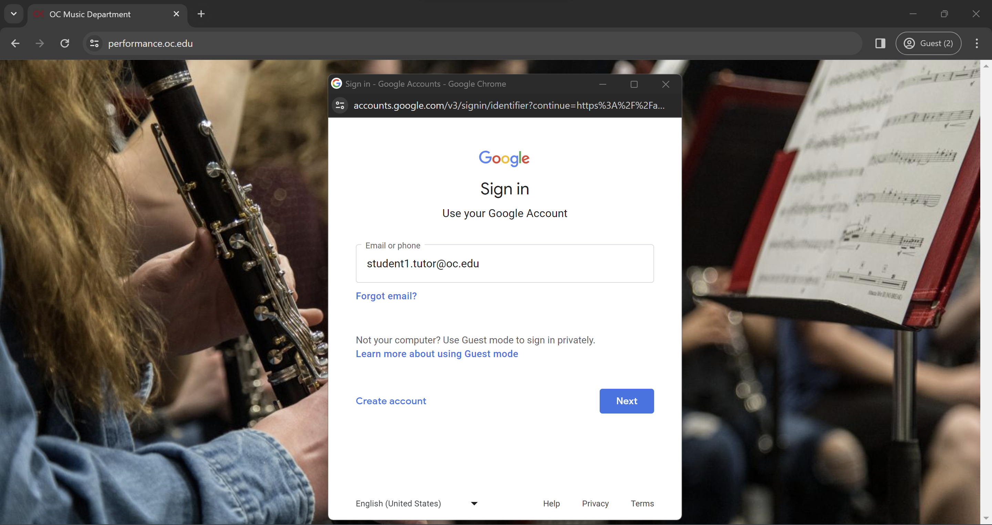

* 1. Enter your **OC** credentials.

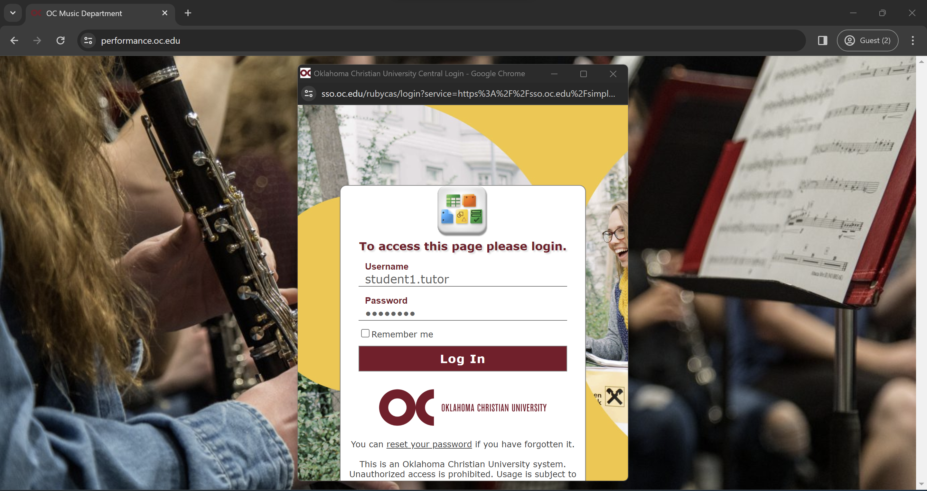

* 1. Click on the account you logged in with.

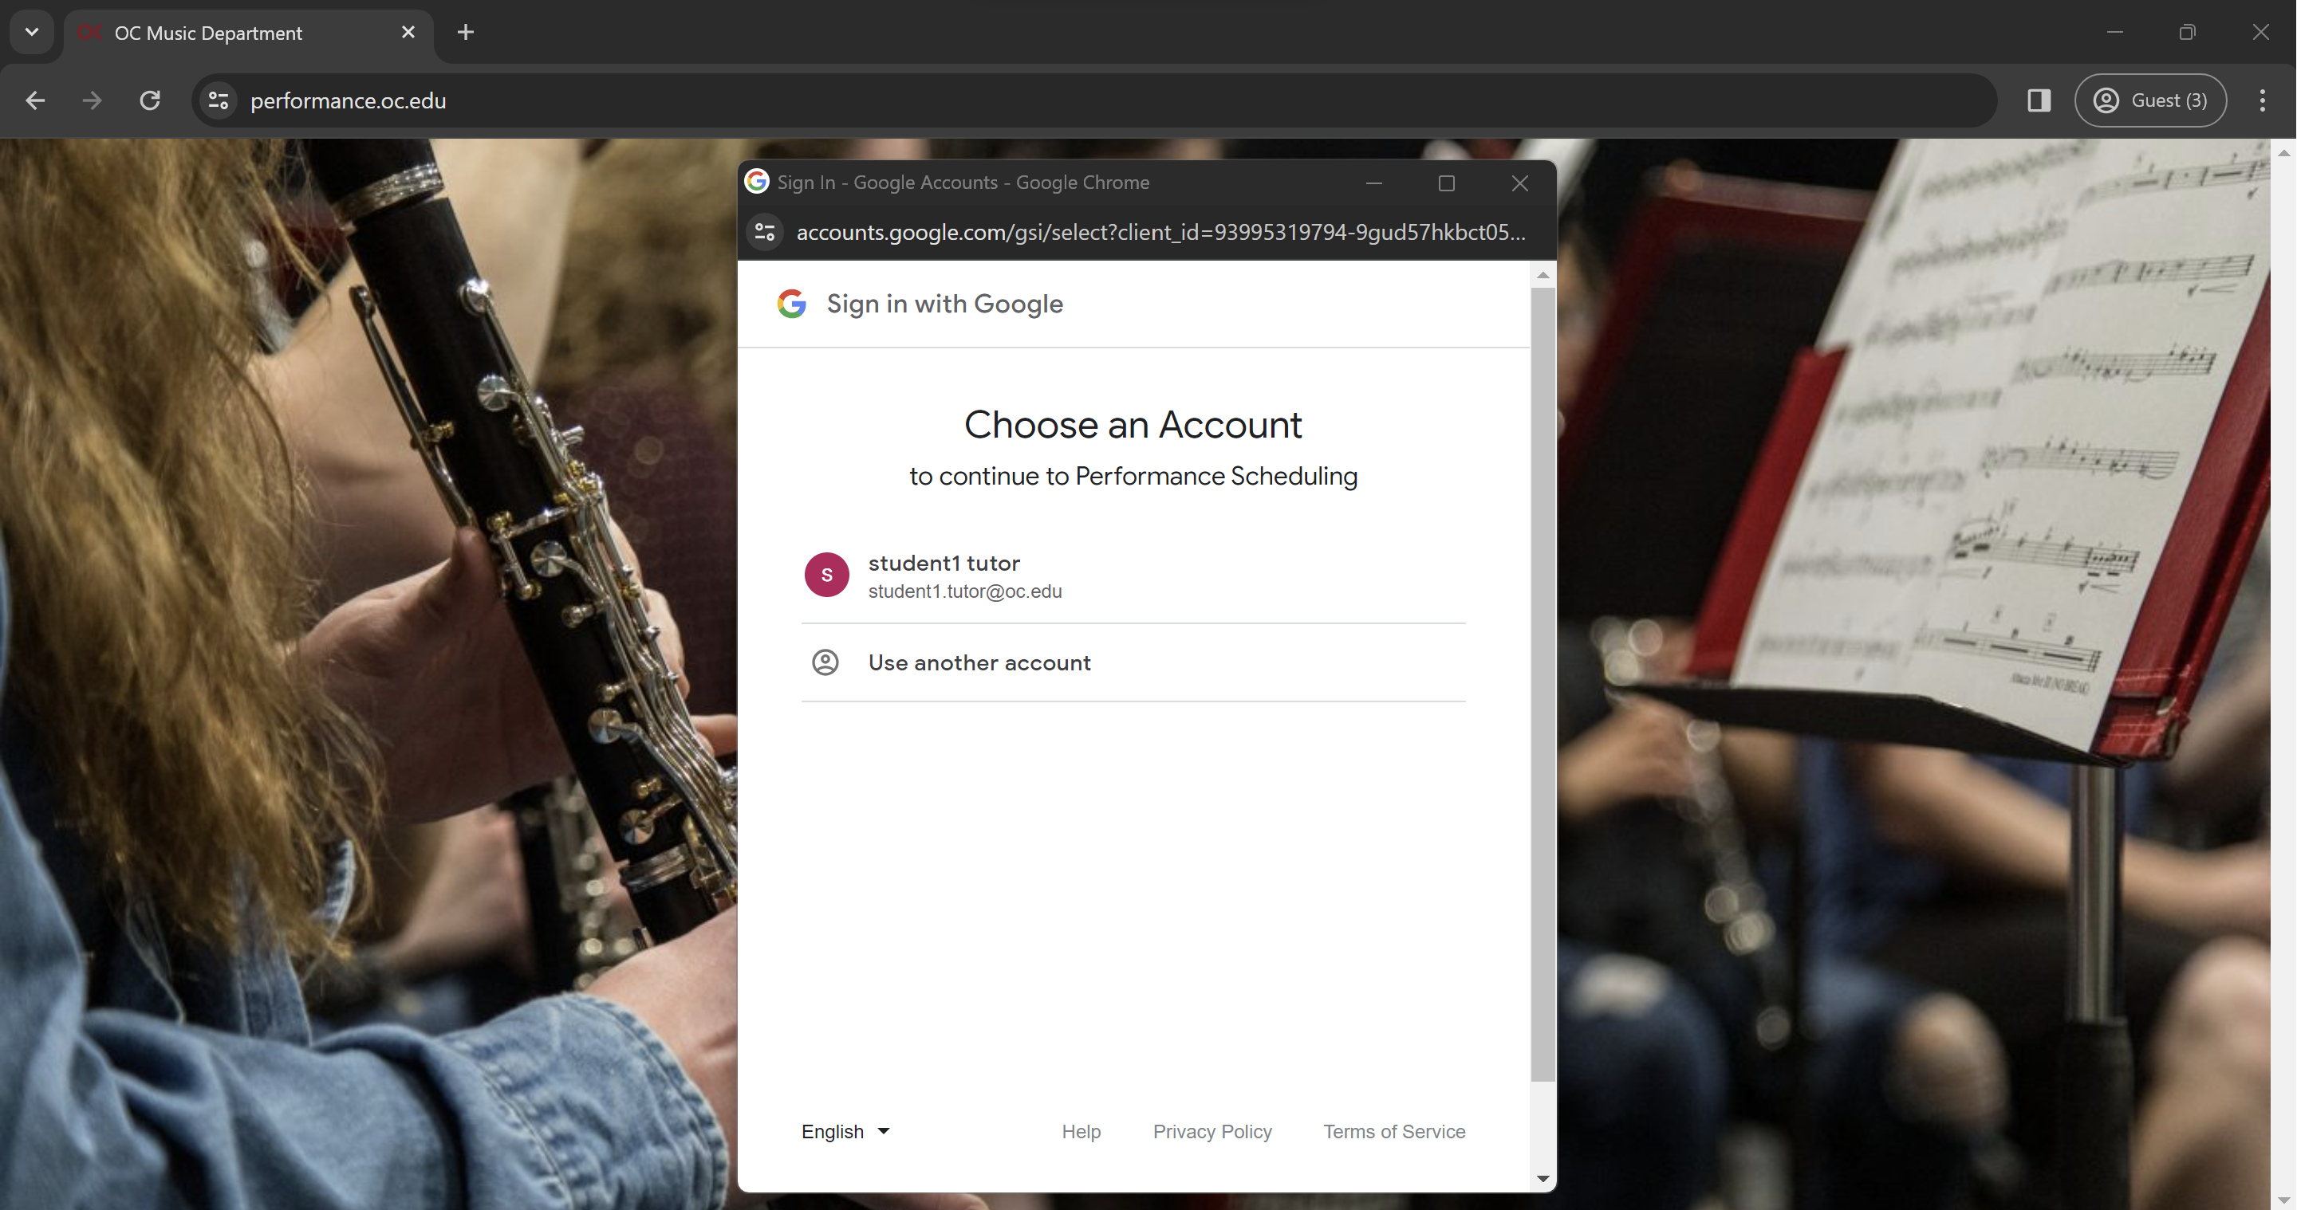

* 1. Google may ask you to give permission to share information with this site. If it does, please give the permission.

## First Time User or in the Semester

* When you log in for the first time, you must activate your account so that you can properly use the website.
  1. Click Activate.

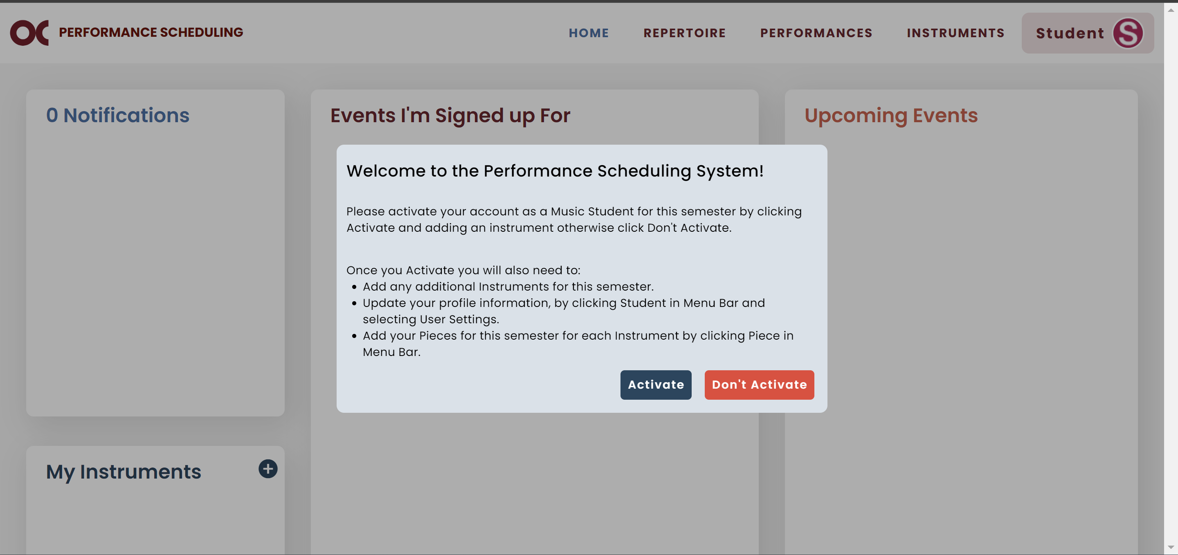

* 1. Add the instrument you will perform this semester (more instructions on page 23).

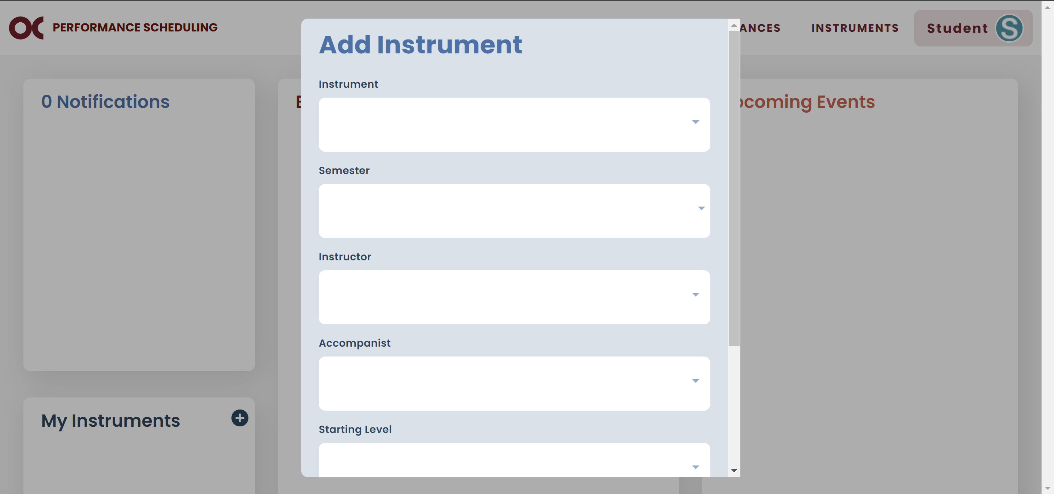

* 1. Click on Student and then User Settings.

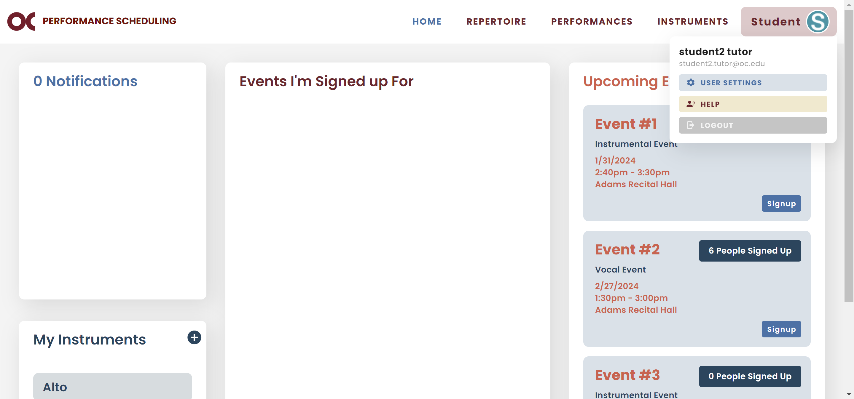

* 1. Update your profile information and click Save.

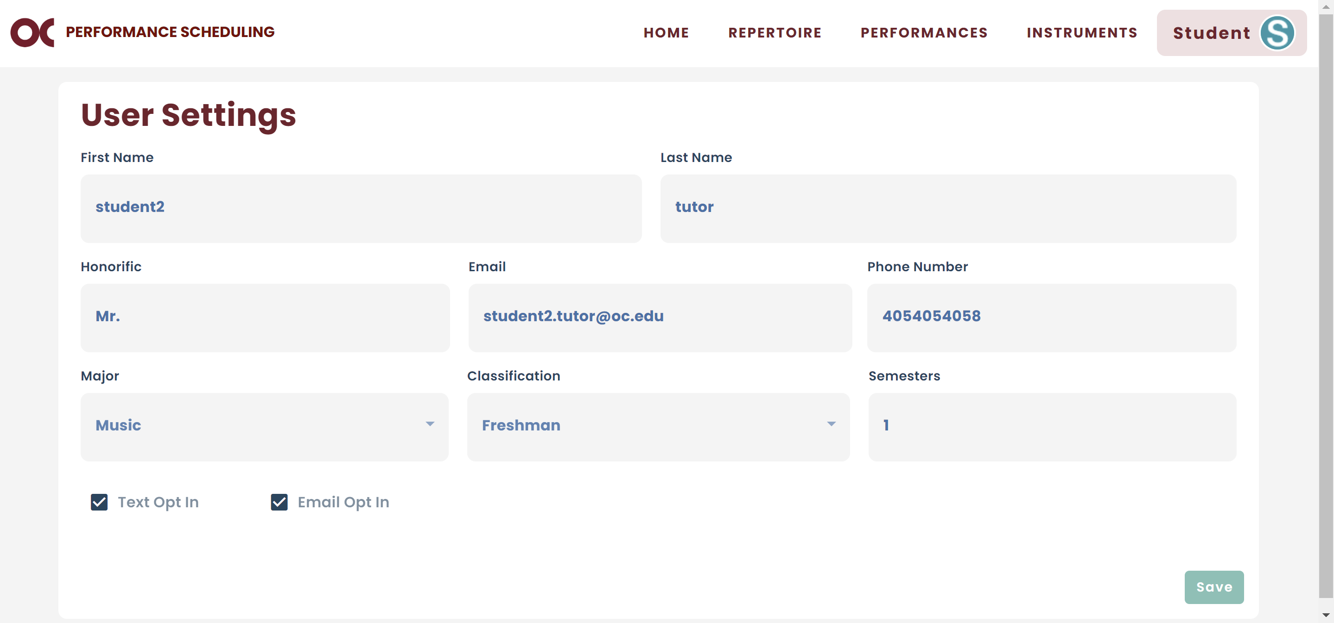

* 1. Go to your Repertoire and add the pieces for this semester (more instructions on page 27).

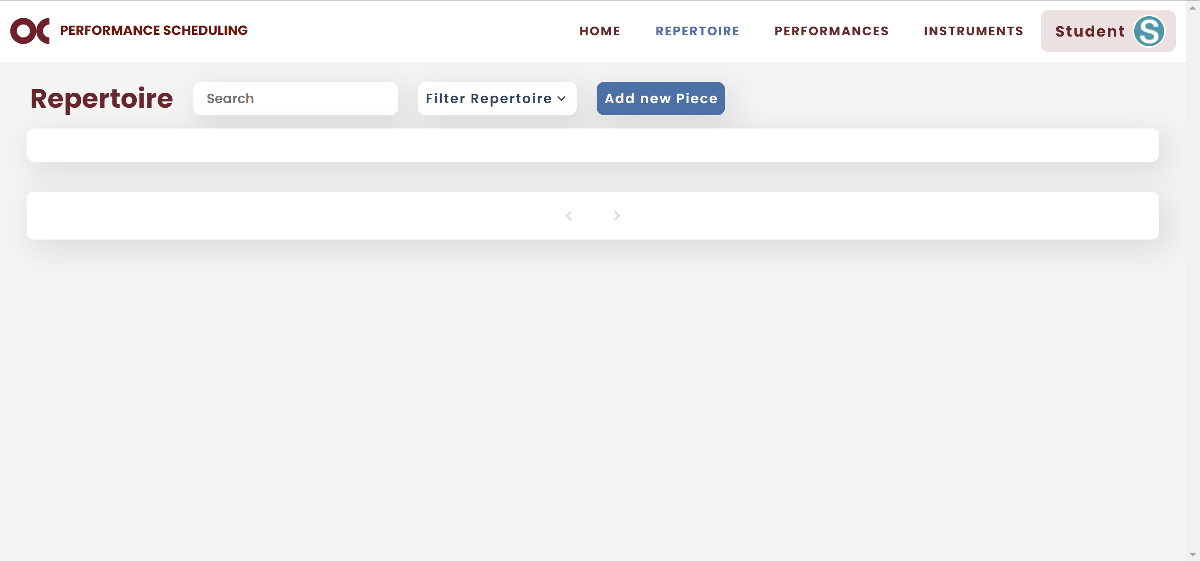

# Event Signups

* You can view all available events on your home screen.

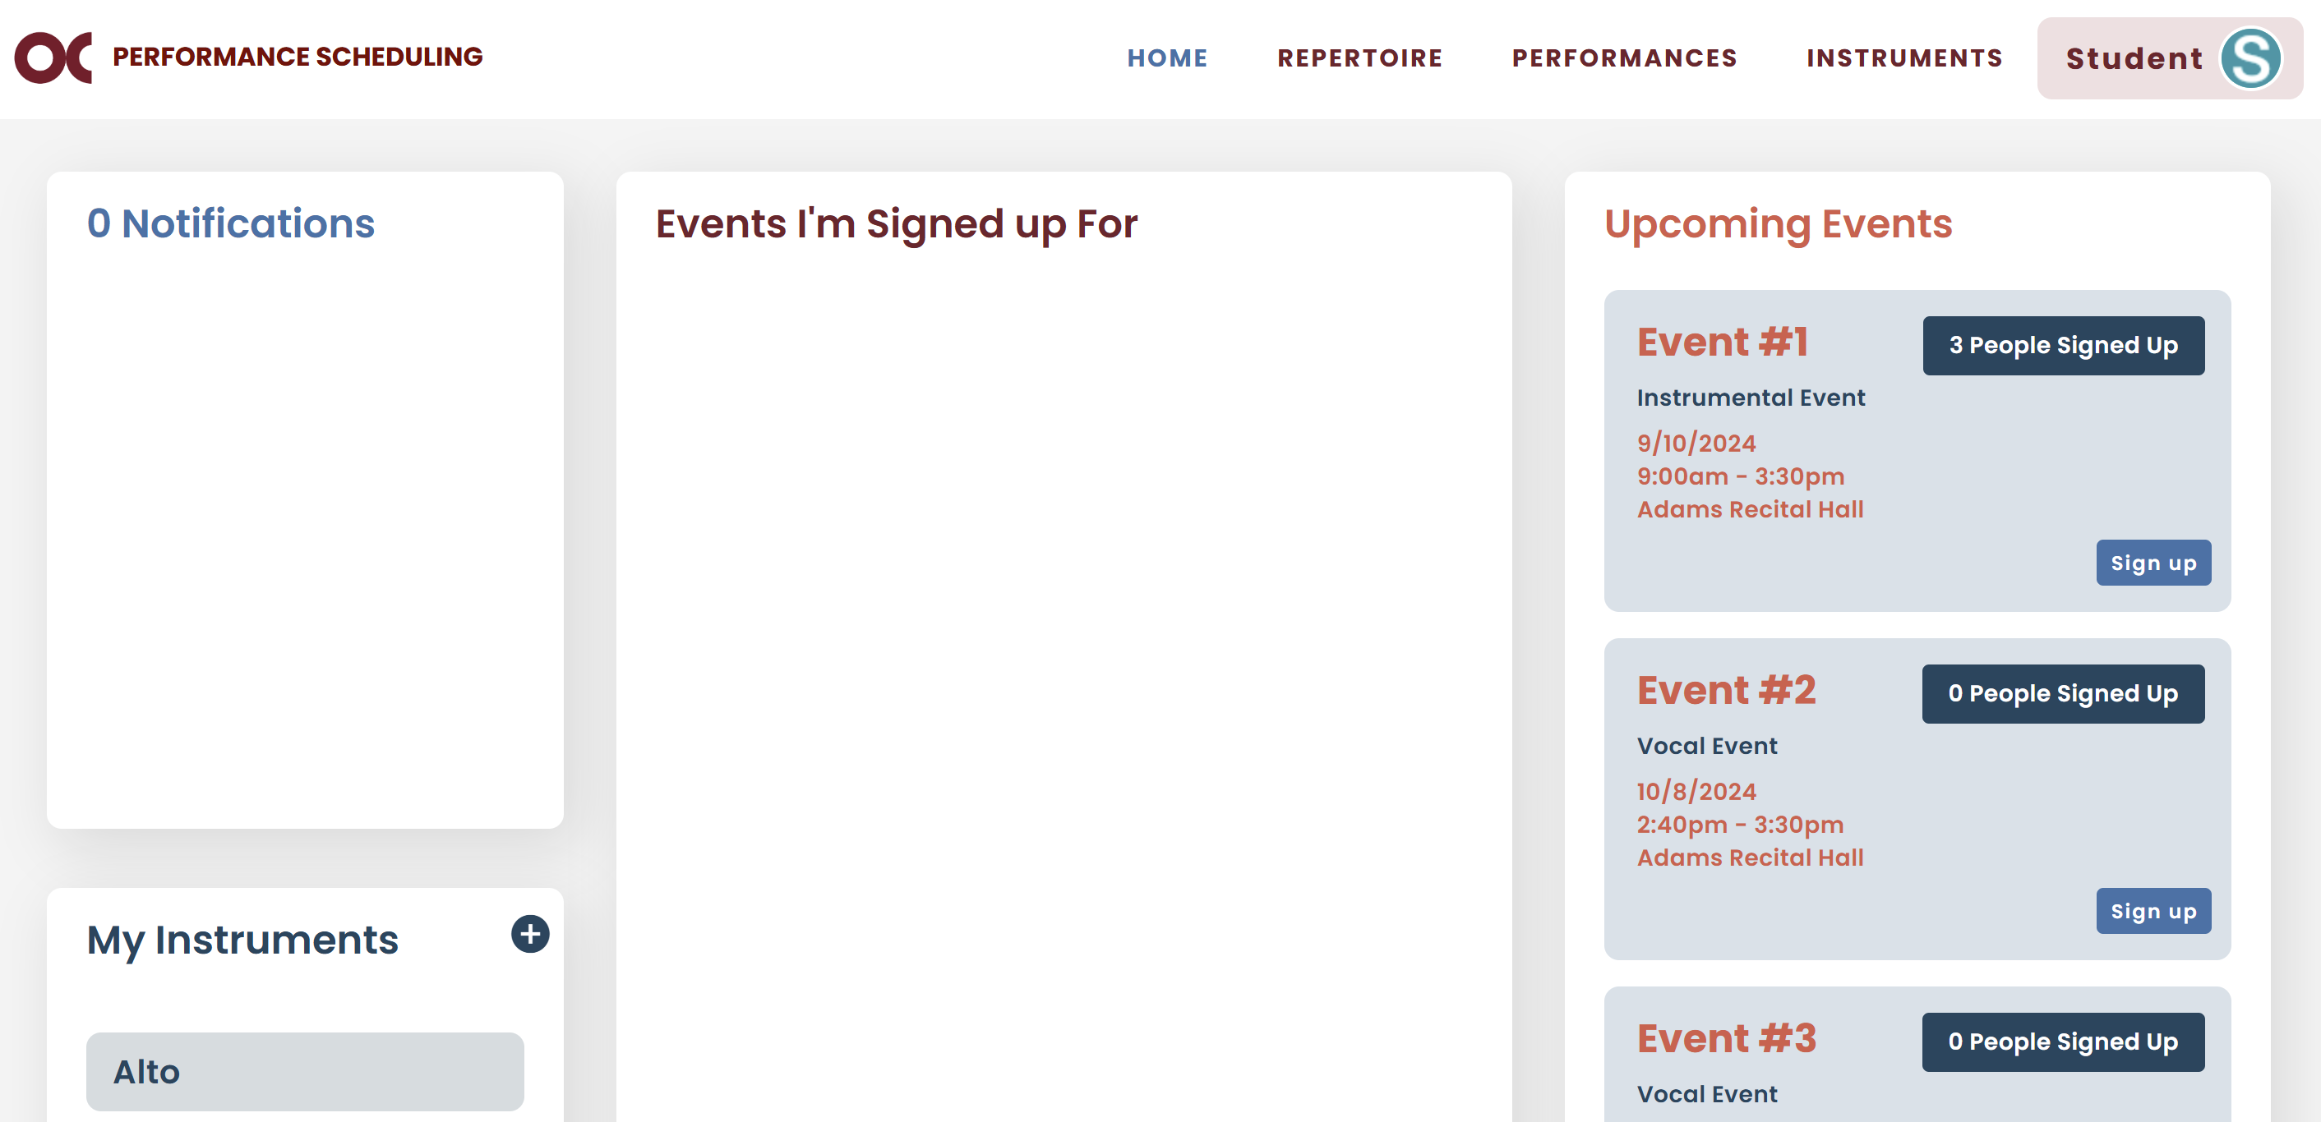

## Sign up for a Time Slot

* You will find your upcoming event and click on Sign up.



* The signup screen will display availabilities for your private instructor and accompanist (if any).
* The grayed-out slots indicate times when the selected instructor and/or accompanist are unavailable. If none are selected, it means that no instructors or accompanists are available during that time.
* The red slots are spots already taken.
* The teal slots are available for sign up.
* The dark green slots are group signups.
  1. Select your instrument.
  2. If your instructor does not need to be present during your performance, you can leave the “Instructor” field blank, which will open up more time slots based on the availability of all faculty members.

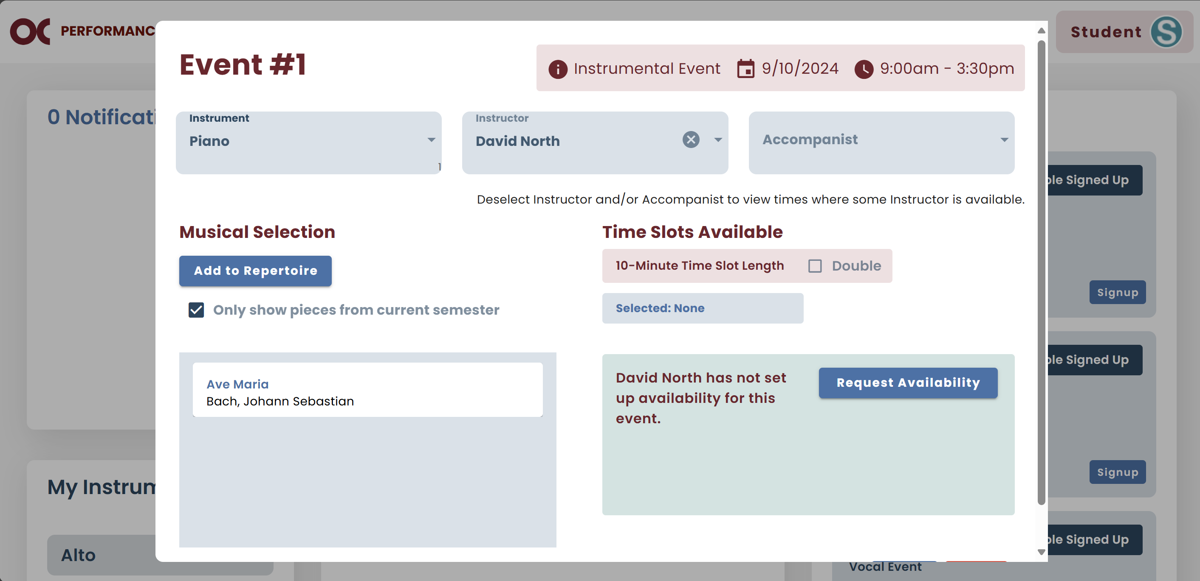

* 1. If you are performing only pieces from the current semester, select the pieces you will be performing.
  2. If not, unselect the checkbox to display pieces from previous semesters, then select the pieces you are performing.

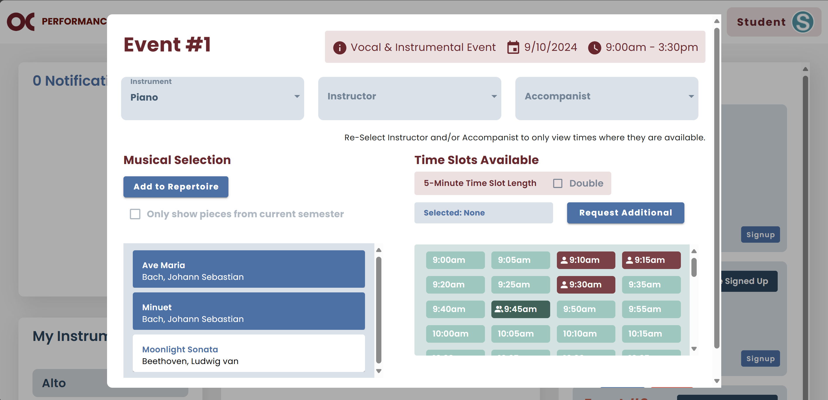

* 1. **Note:** if it is a Jury event, you will have to indicate which piece you are performing first. To do so, select “Set as First Piece”.

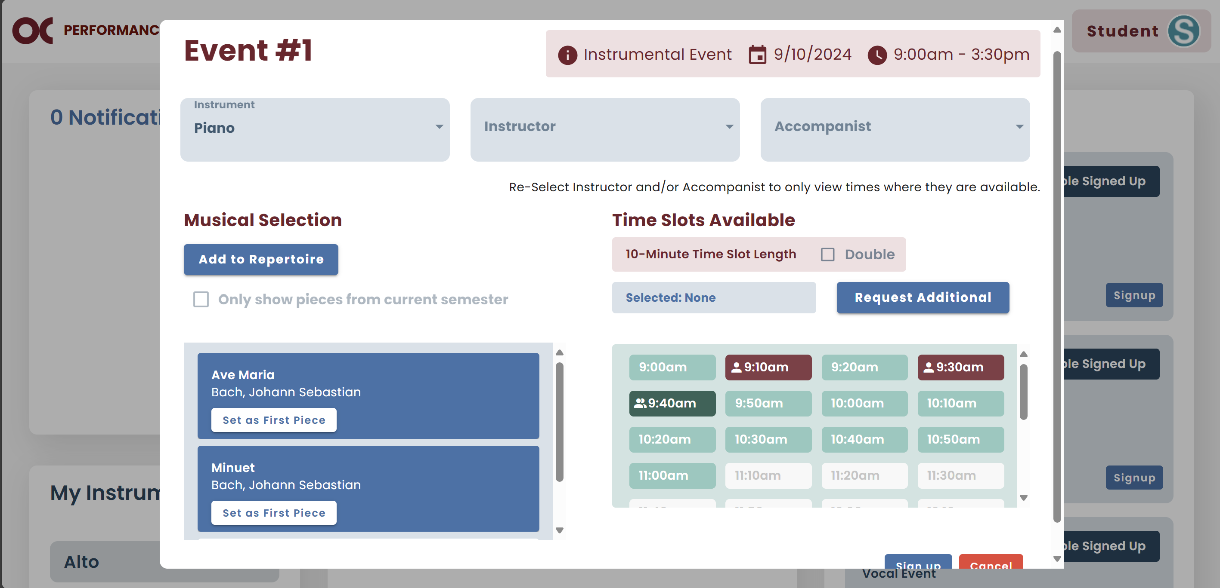

* 1. If you need more time than the available time slots allow for your performance, select "Double." This option will double the time of each slot, giving you additional time to complete your performance.

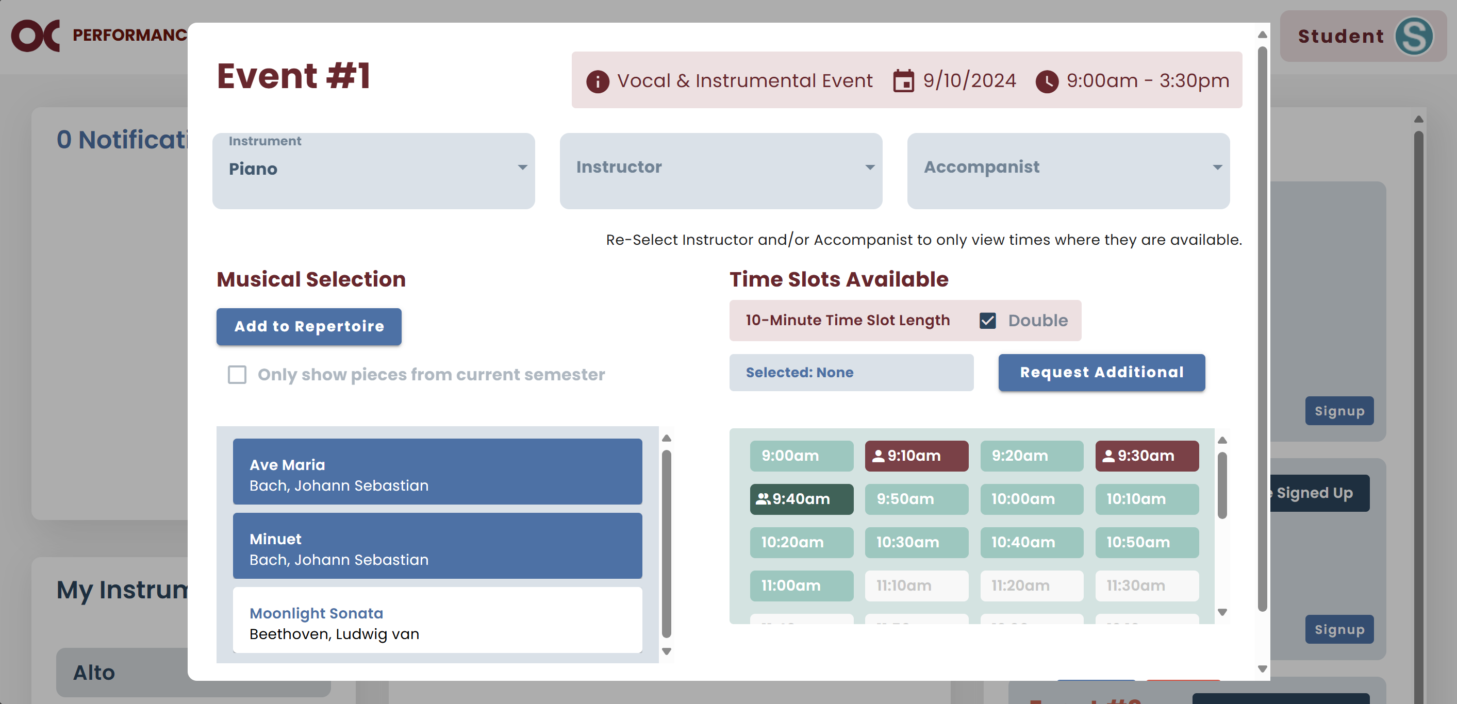

* 1. Pick one of the teal time slots.

### Individual Signups

* 1. Scroll down and click Sign up.

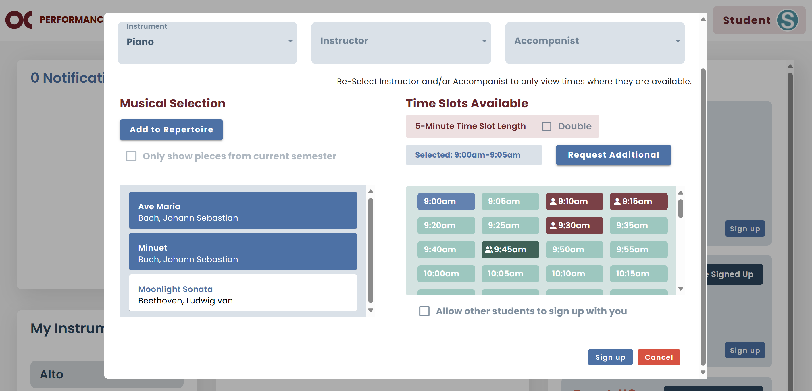

* 1. If all the information is correct, click Confirm.

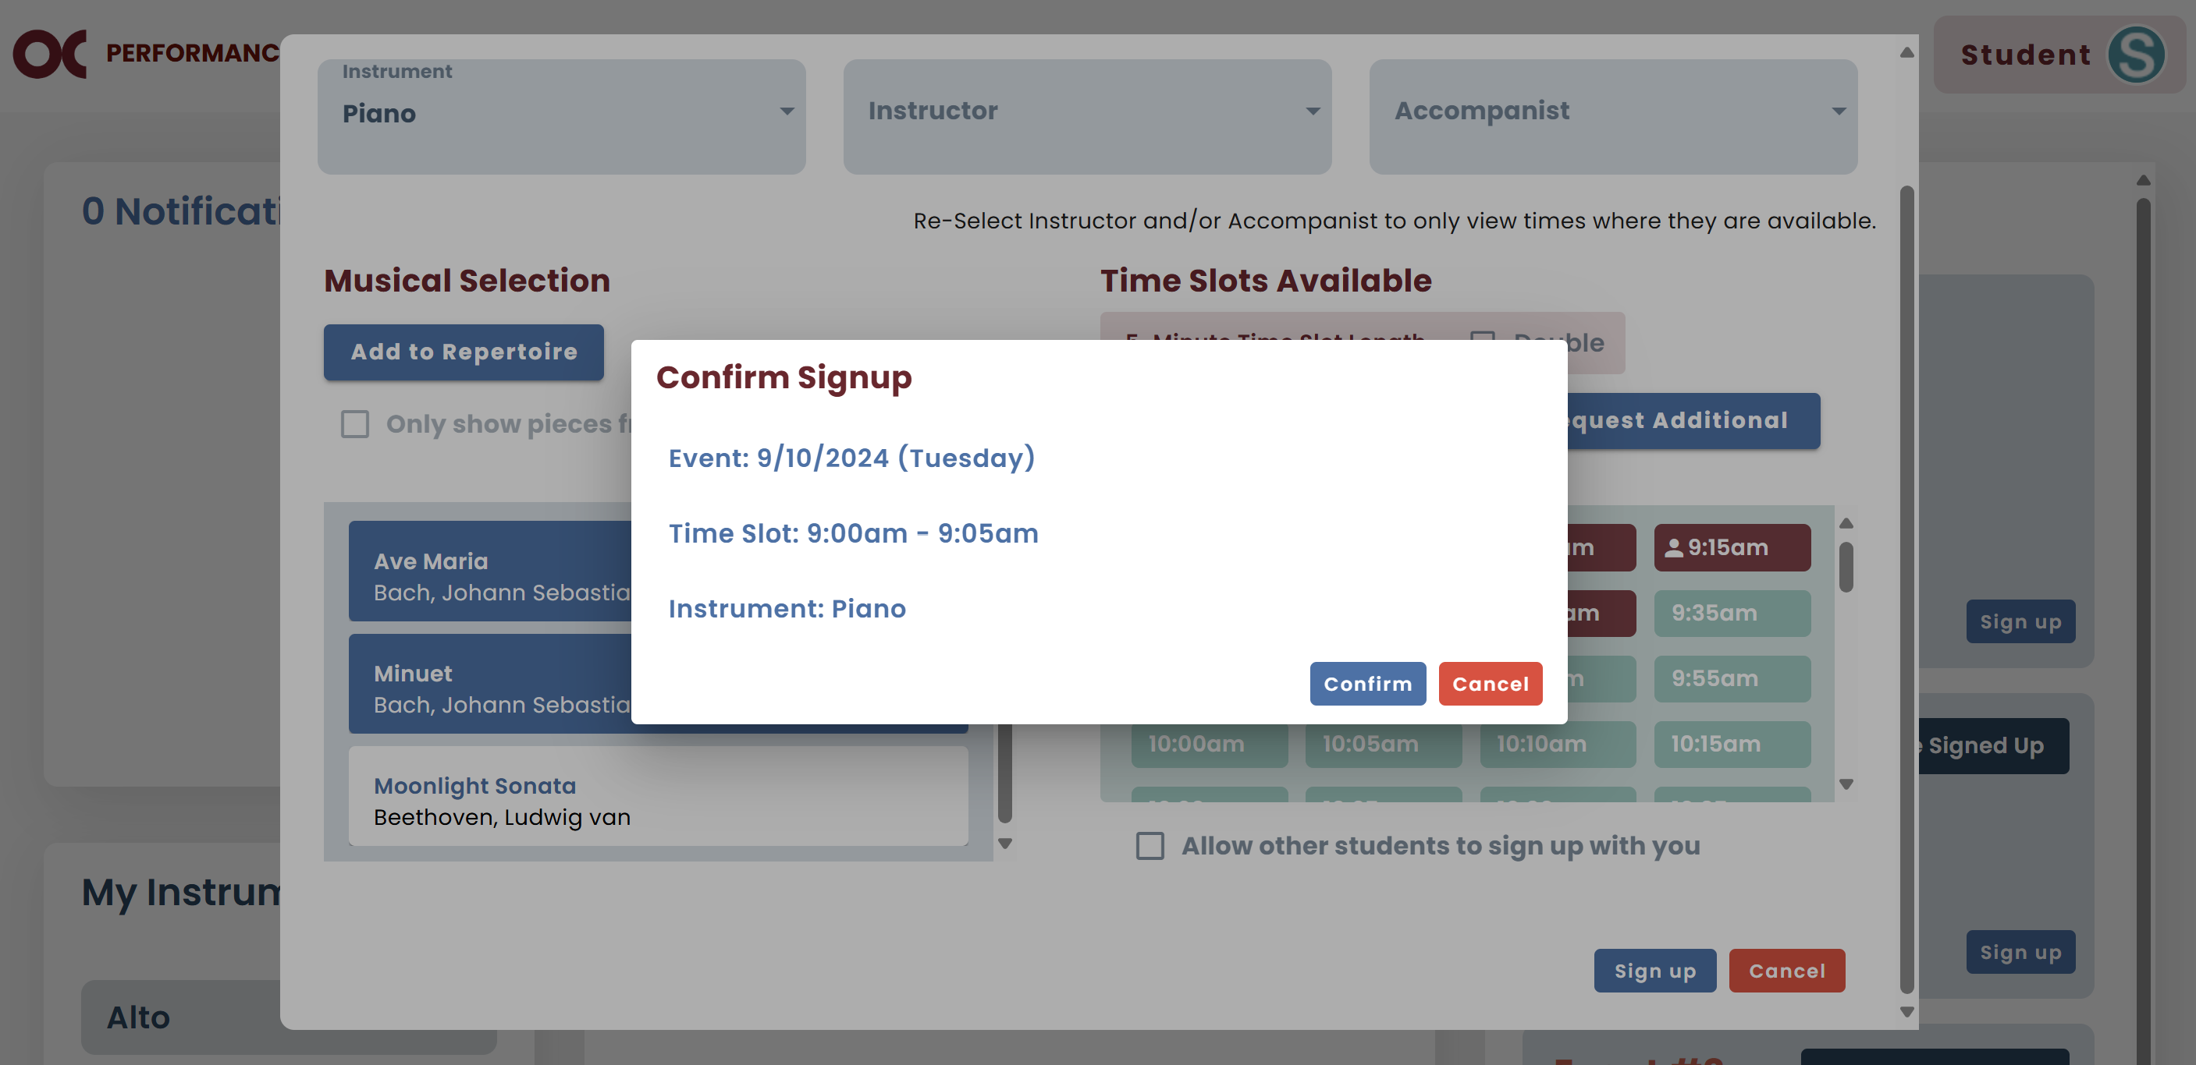

* 1. Now your signup will show on your home screen.

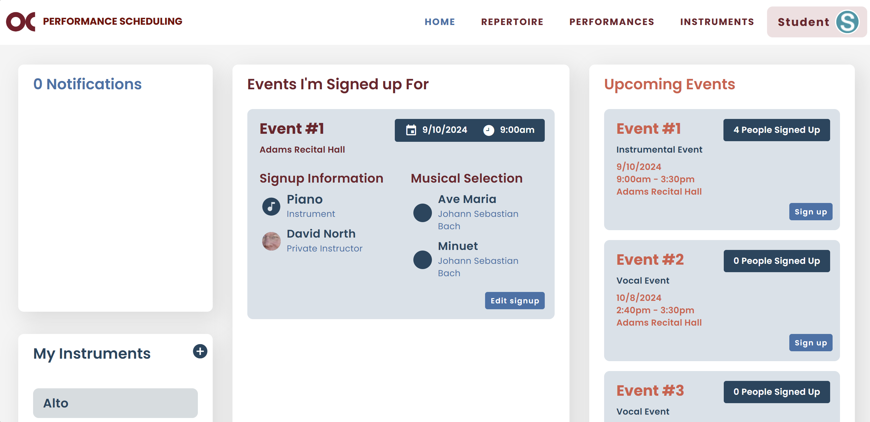

### Group Signups

1. If you are the first member of the group to sign up, select an available time slot, then select the group checkbox, and click Sign up.

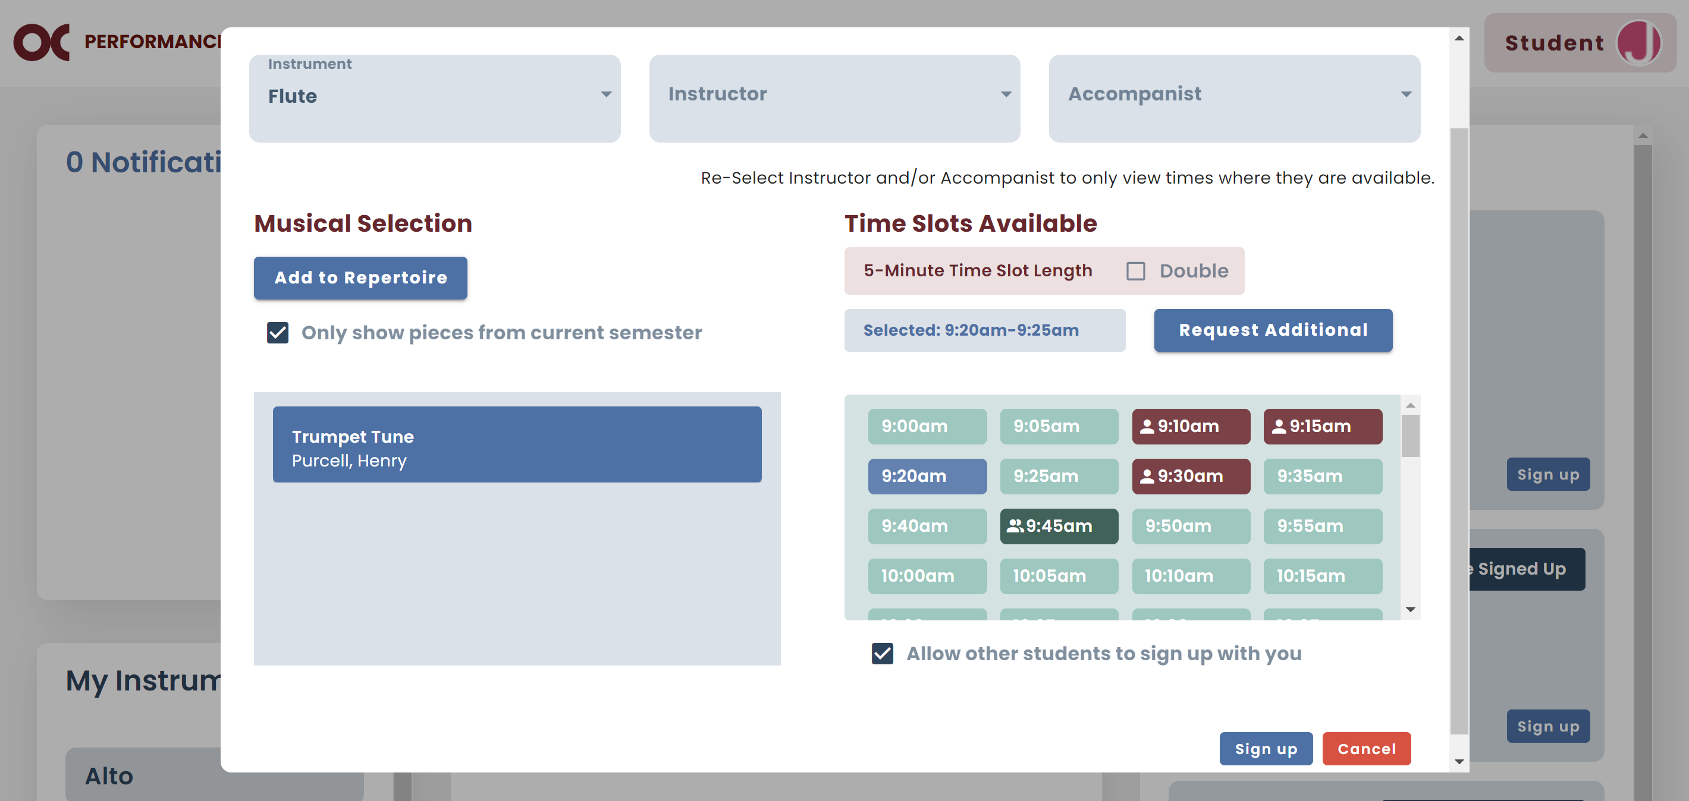

1. If you are any other member of the group, select the dark green time slot that your group signed up for.

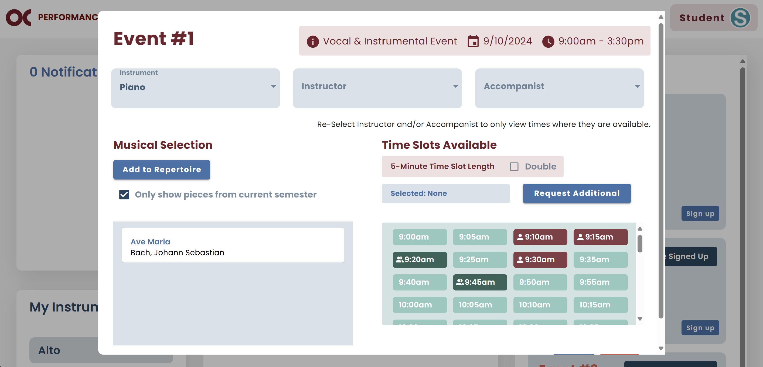

1. If the pieces chosen by the first group member are not in your repertoire, you will need to add them.

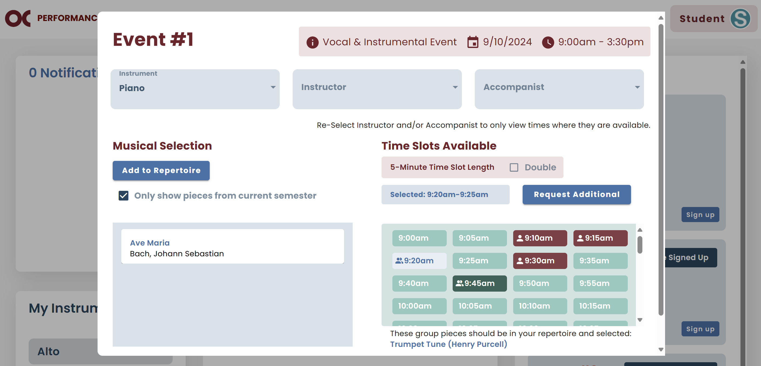

1. Once you add them, click Sign up.
2. If all the information is correct, click Confirm Group Signup.

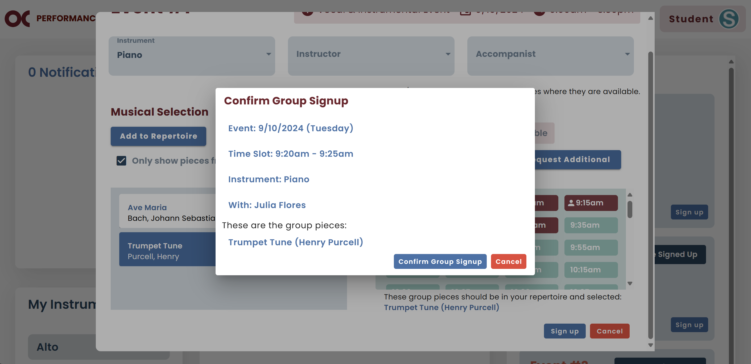

## Request Time Slot

* In case the only time slot you can perform is already taken, you can request that slot from the person who signed up for it.
* The person will receive a notification on their home screen and via email.
* If they are able to switch to another time slot, they can delete their signup and choose a different time.
* **Note:** It is recommended that the student notify the requester via email once the requested time slot becomes available.
  1. Select your piece.
  2. Select the occupied time slot you want and click Sign up.

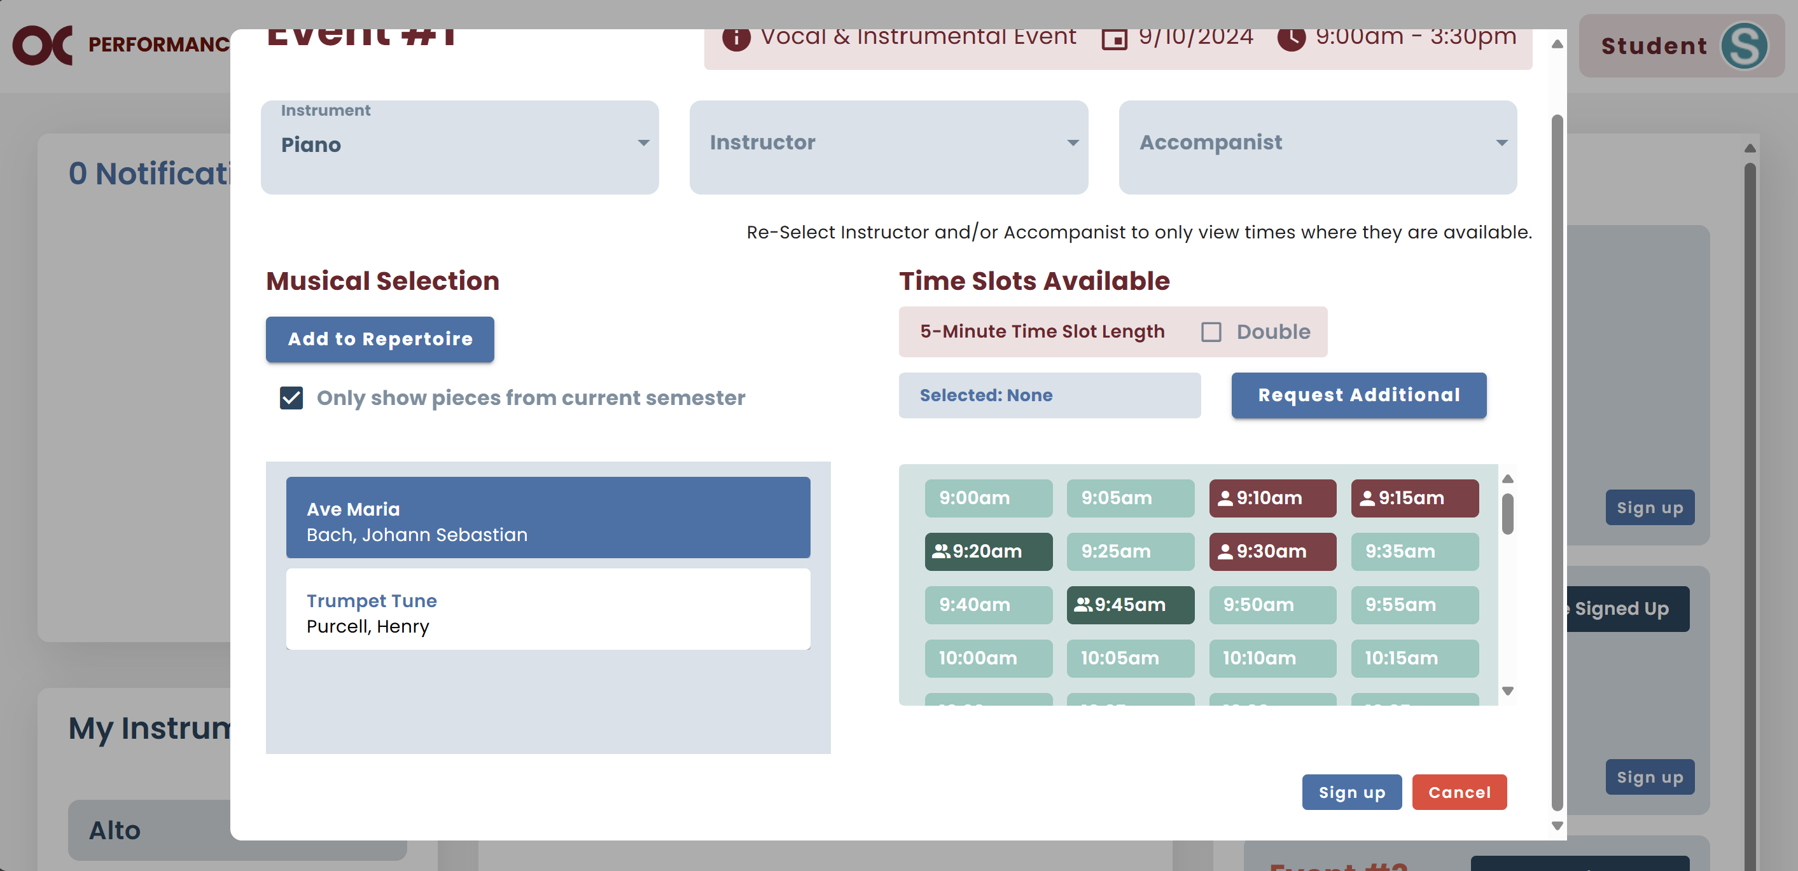

* 1. If that is the desired time slot, click Request This Timeslot.
  2. **Note:** The message will display the name of the person for whom you are sending the request.

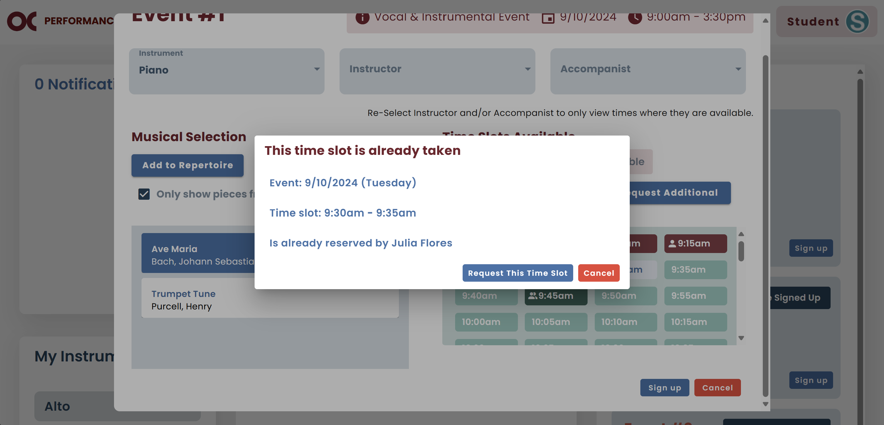

## Request Additional Time Slots

* In case there are no slots that work for you, you can request additional time slots.
* Your request will be sent via email to the admin and your instructor, and they will be able to add extra slots.
  1. You will click on Request Additional.

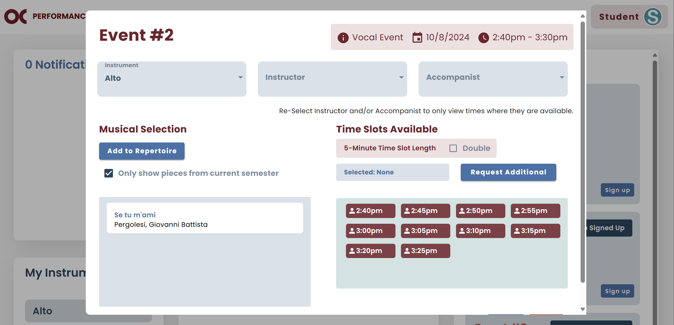

* 1. If you are sure about your request, click Send.

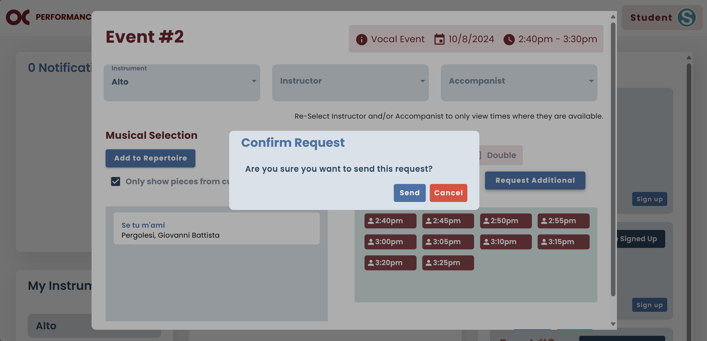

## Request Availability

* In case your instructor needs to be present at your performance and has not entered their availability yet, you can send them a request.
* The same applies to accompanists.
* They will receive an email requesting to set up their availability for that event.
  1. Click on Request Availability.

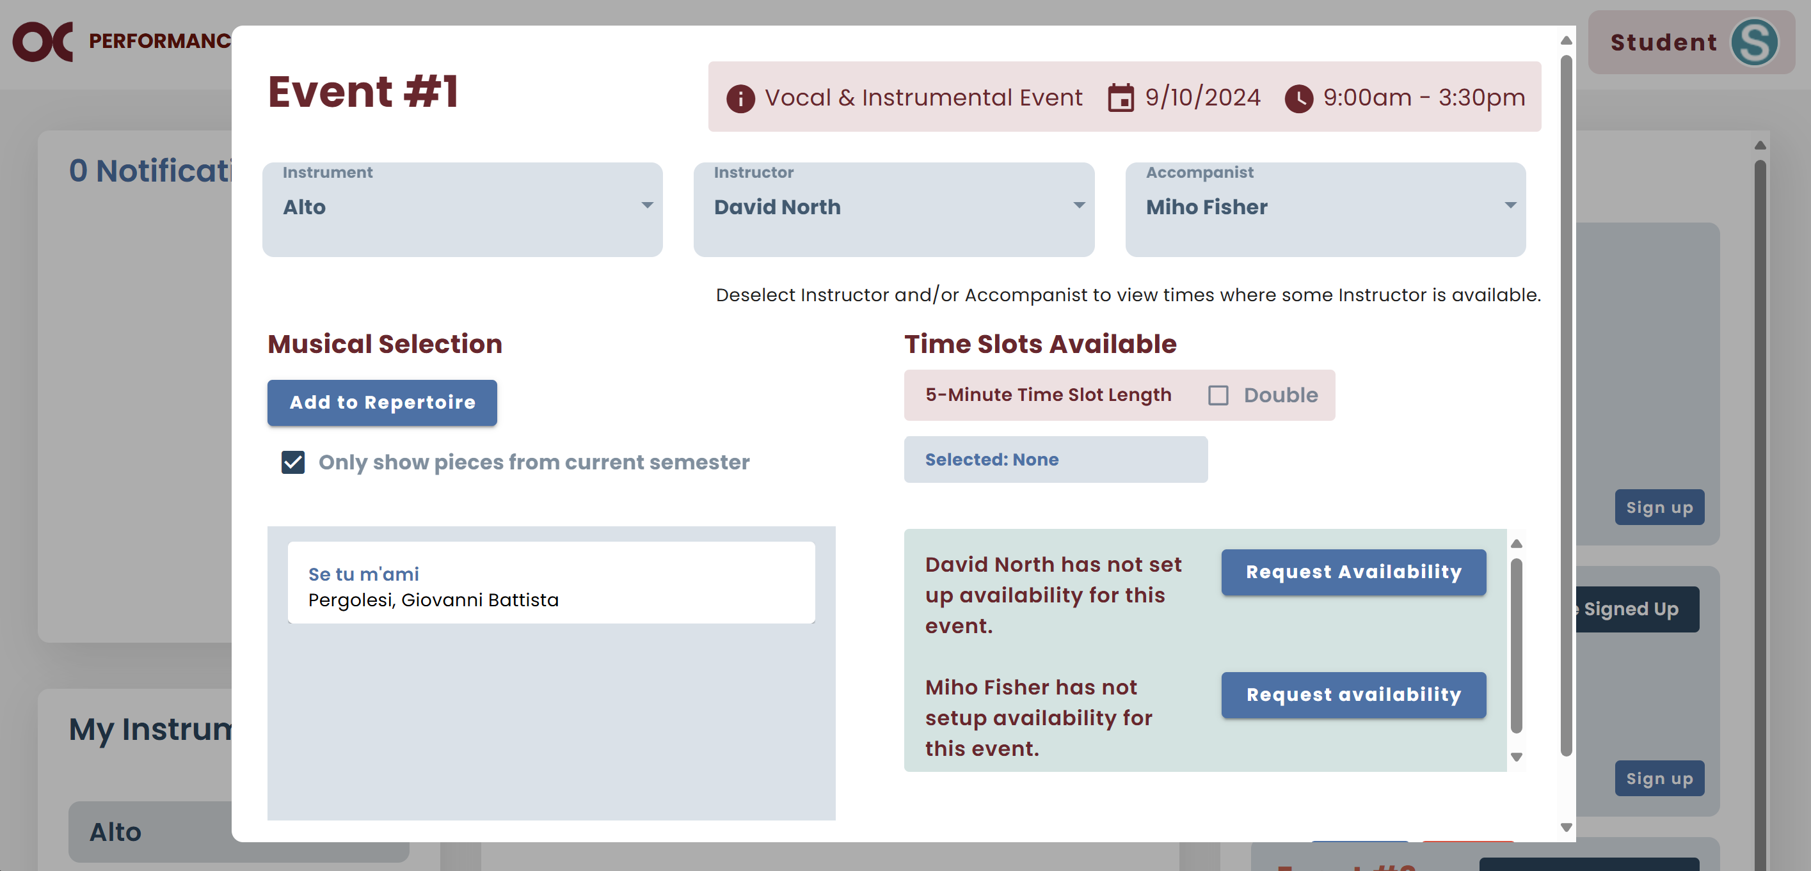

* 1. If you are sure about your request, click Send.

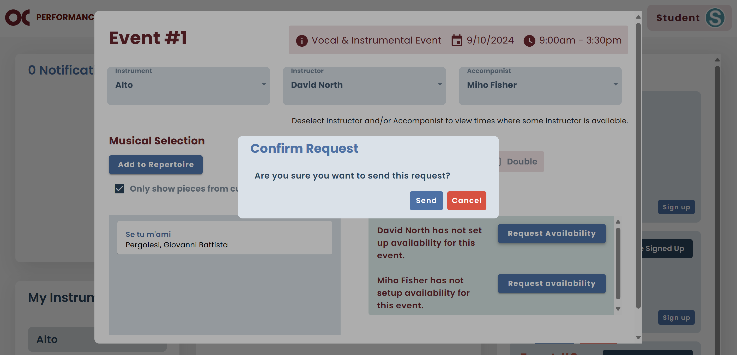

## Edit Signup

* If you want to update the information, go to the Events I’m Signed up For column and click Edit signup.



* You can edit the pieces you will perform or allow other students to perform with you. Once that is done, click Save.

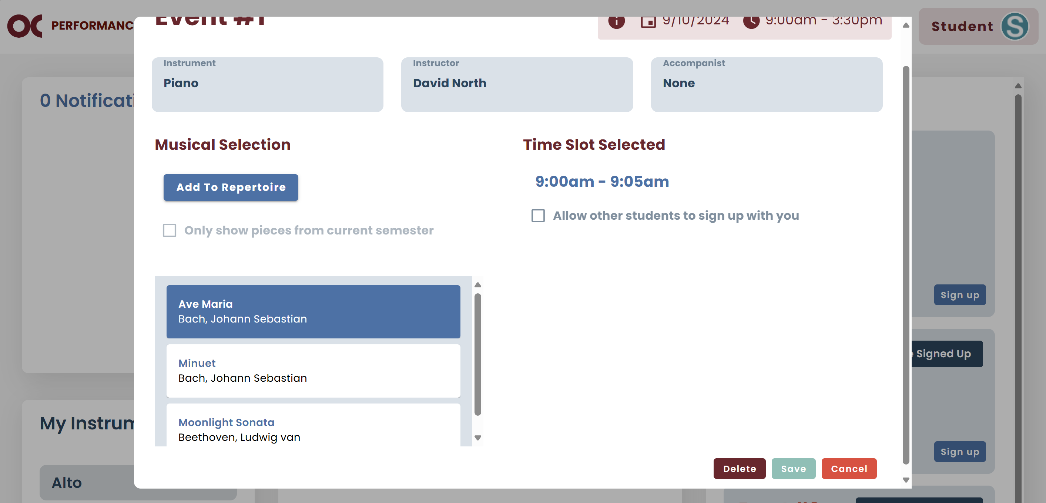

## Delete Signup

* If you cannot perform on the time slot you are currently signed up for, you can delete it.
  1. In the same dialog you edit your time slot**,** select Delete.



* 1. If you are sure you want to proceed with the deletion, click Confirm.

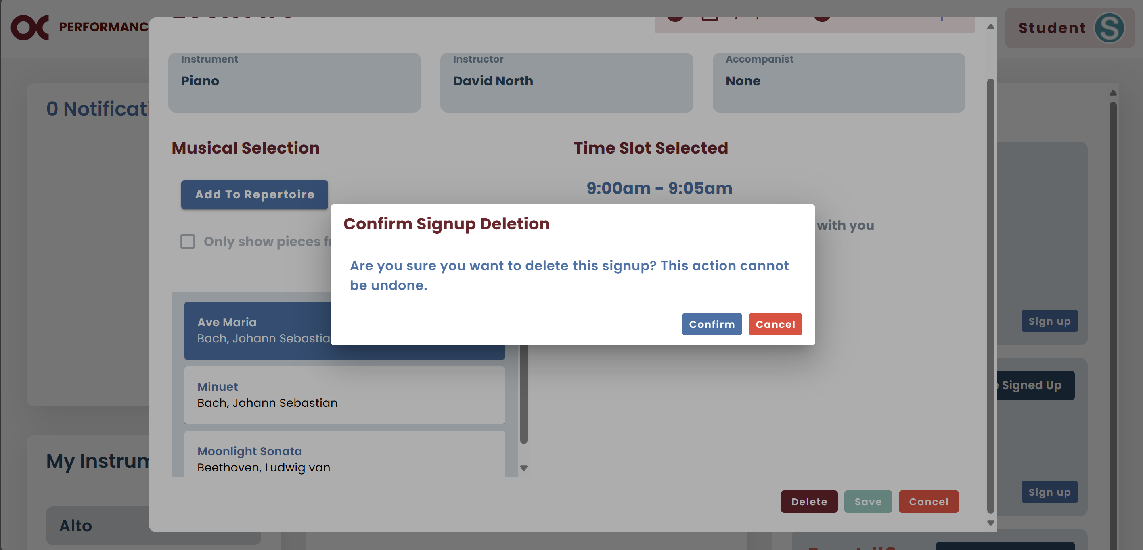

# Performances

* You can check your previous performances information by selecting Performances.

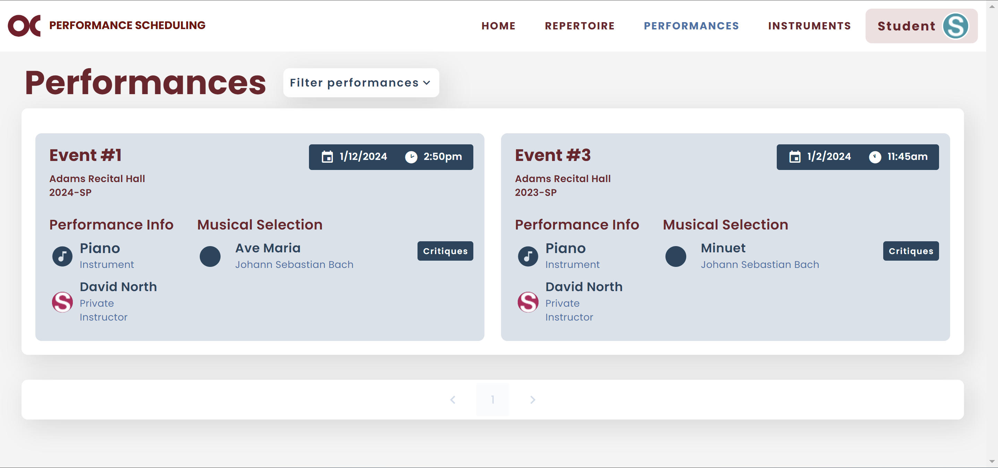

* You can check the critiques for a specific event.
  1. Find the performance you want.
  2. You can filter them by semester and/or instrument. You must select your option and click “Apply Filter”.

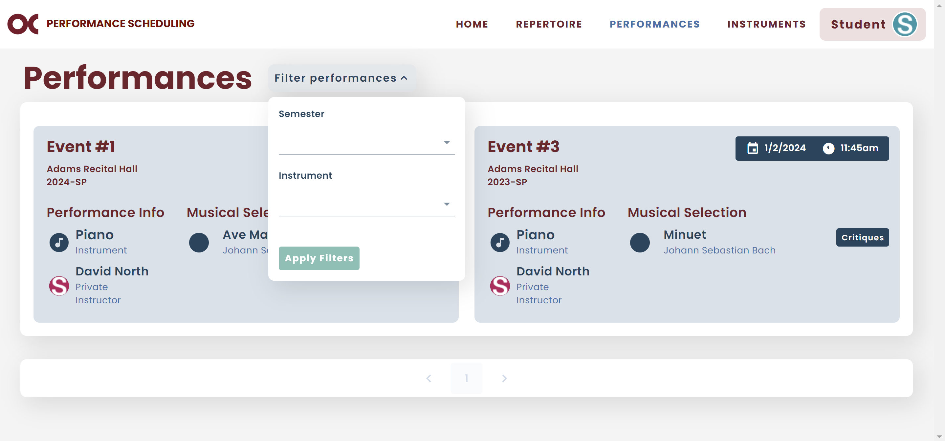

* 1. If you do not want to use the filter anymore, click Clear Filters.

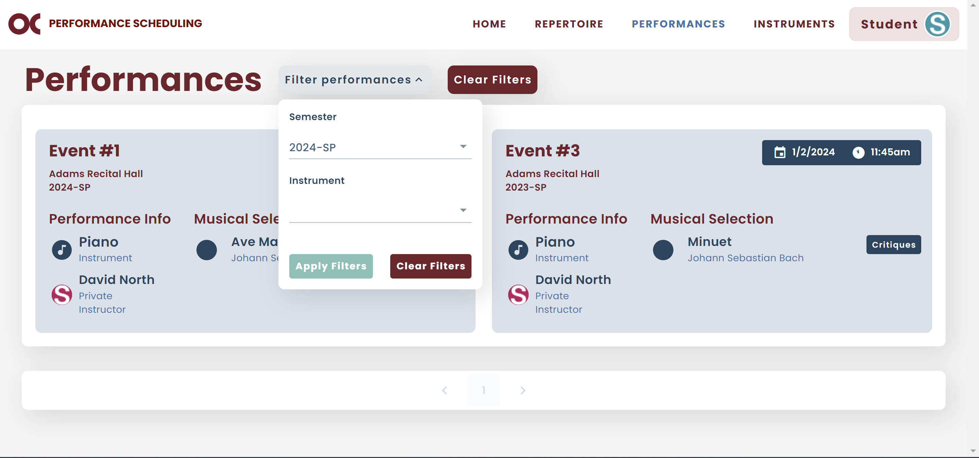

* 1. If you want to view your critiques for a specific performance, select Critiques.



* 1. You will see a list of all instructors that critiqued your performance.

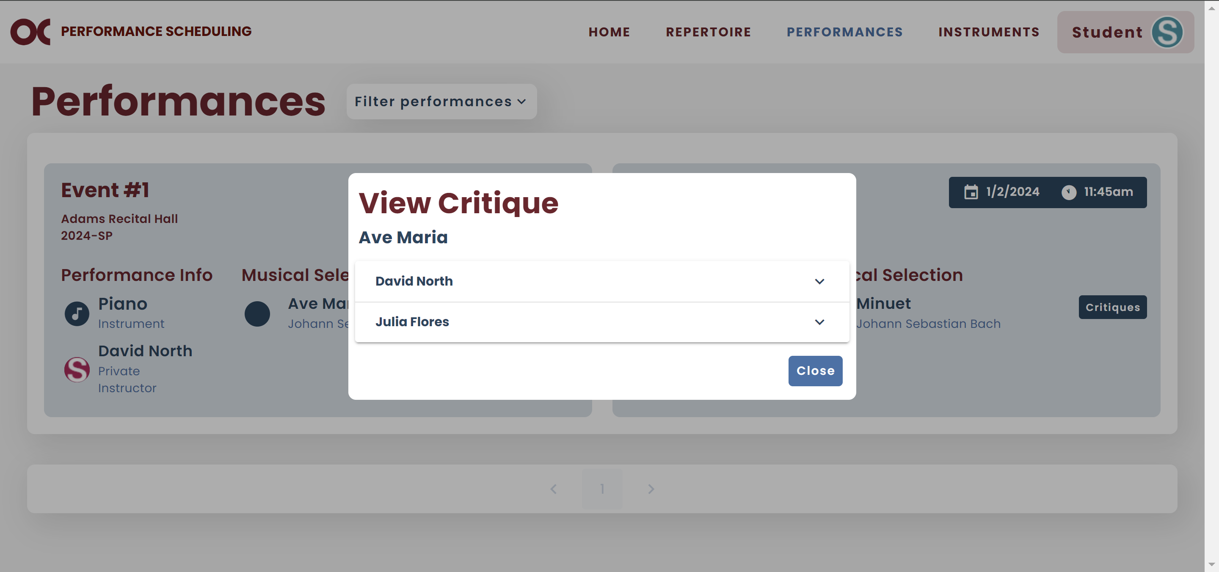

* 1. Select the instructor that you want to view the critiques.

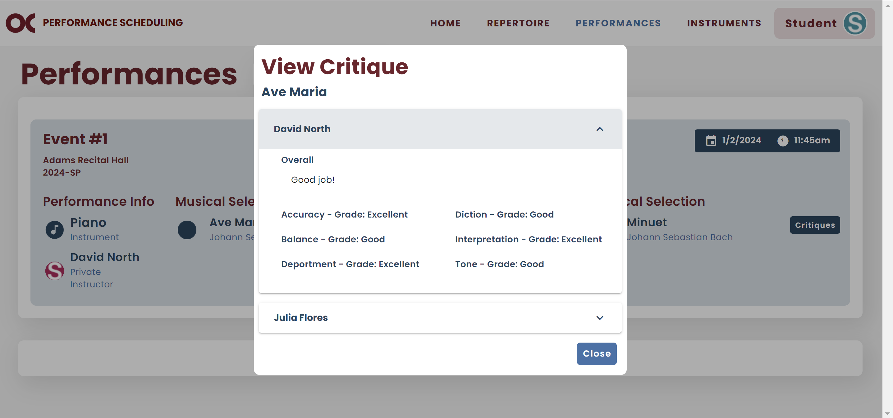

# Instruments

* You can view all your instruments on your Instruments screen.

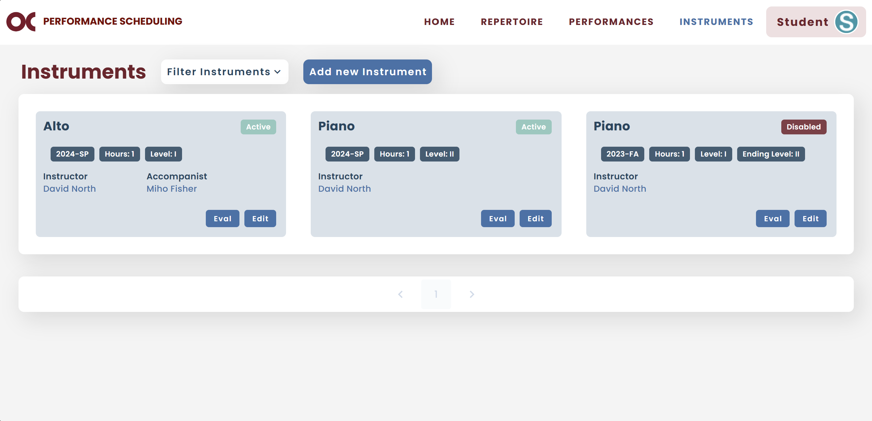

* Your previous semester instruments should be Disabled and your current ones Active.
* You can filter them by status or semester.

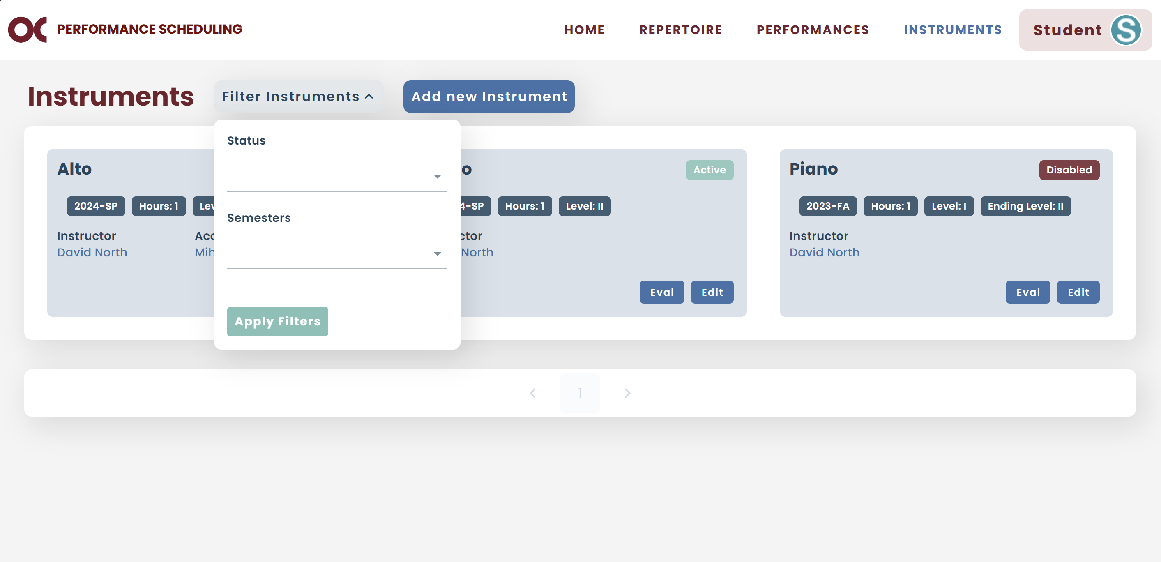

* If you want to add a new instrument, click Add new Instrument.



* 1. To add a new instrument, you first have to select which instrument.
  2. The semester will default for the current one.
  3. If it is an instrument that you already had for previous semesters, the information will automatically be filled out.
  4. If not, select who will be your private instructor.
  5. If you have an accompanist, select your accompanist.
  6. If it is your first time selecting this instrument, your starting level will default to I. If you had selected this instrument previously, it will default to your ending level from your most recent semester.
  7. Add how many credit hours per week you are taking private lessons (should be 1 or 2).
  8. Once all the information is completed, click Add.

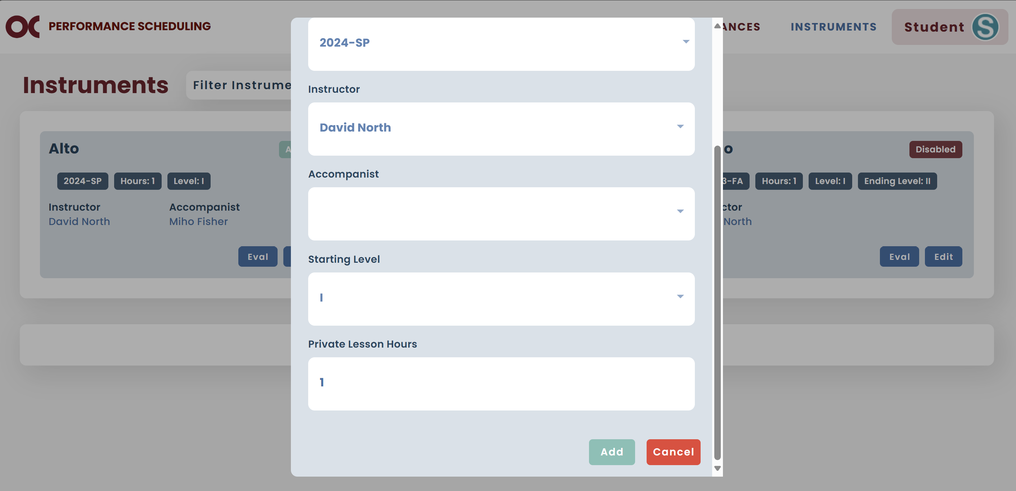

* 1. Now your new instrument is added to your profile.

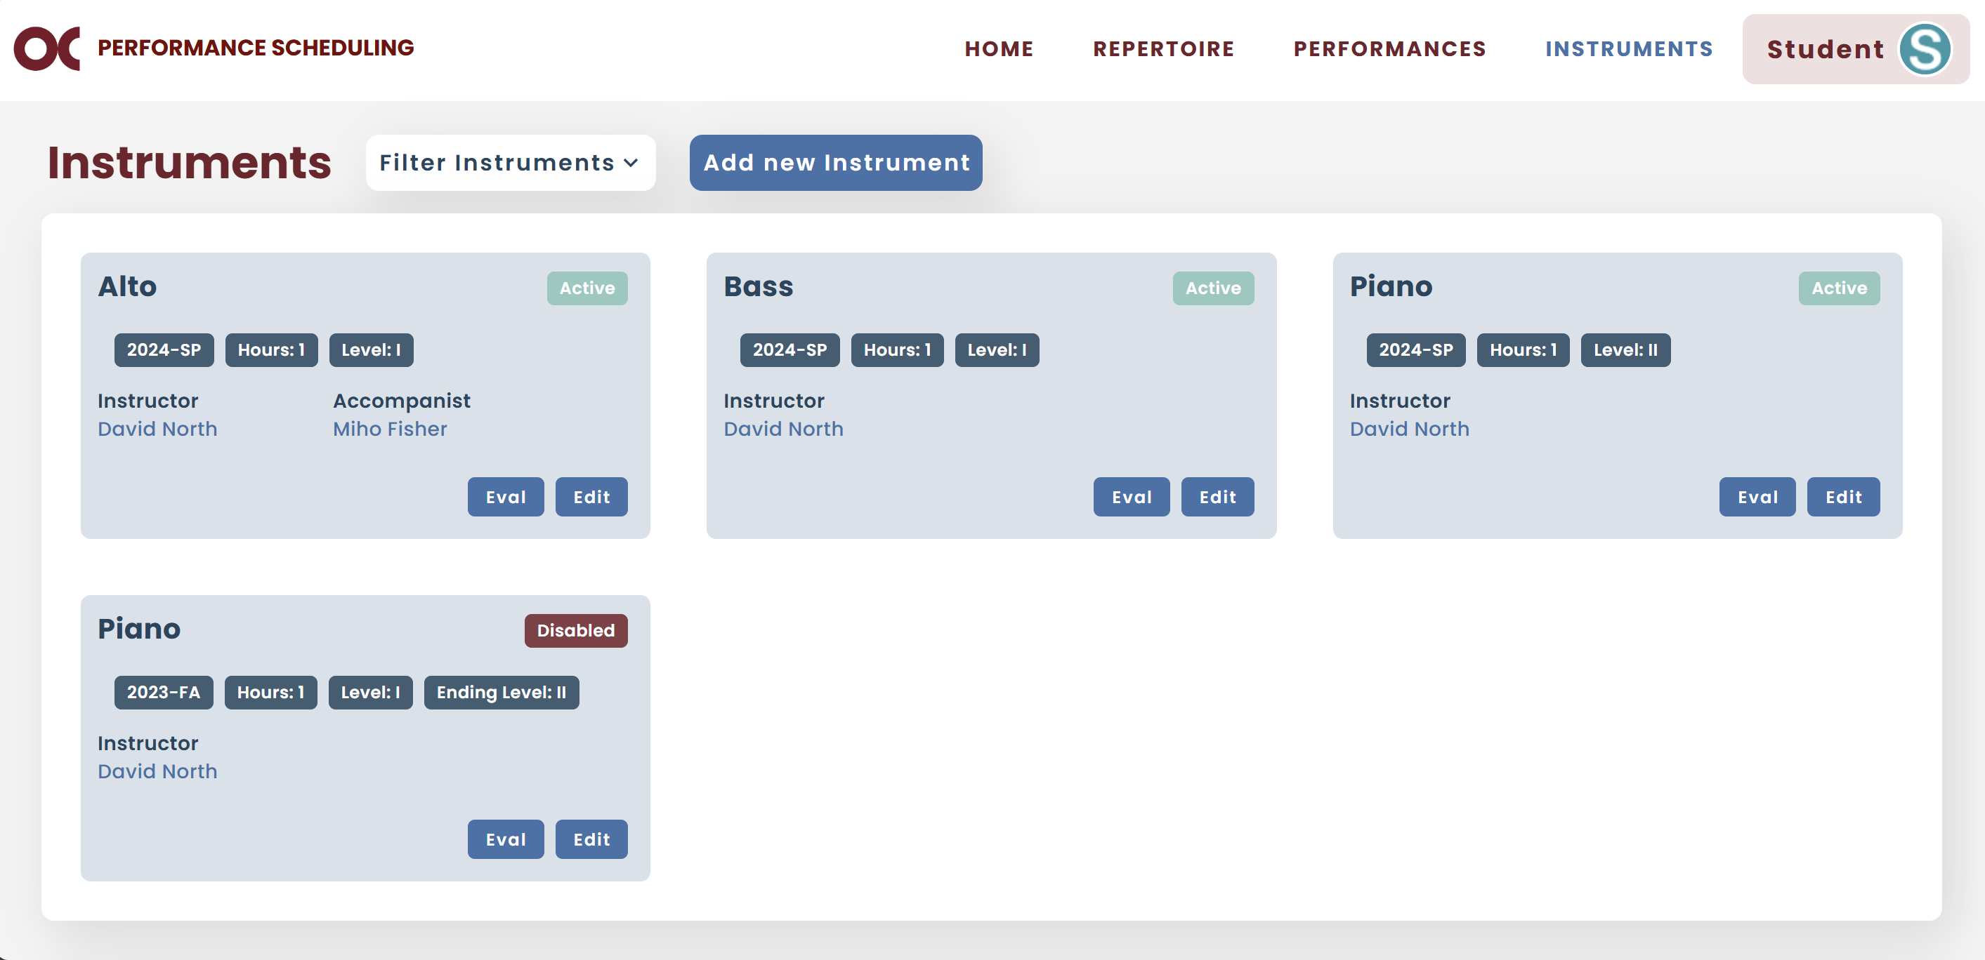

* You can check your beginning/mid/final evaluations entered by your private instructor.
  1. Find the instrument and click Eval.



* 1. Select the term you want to check.

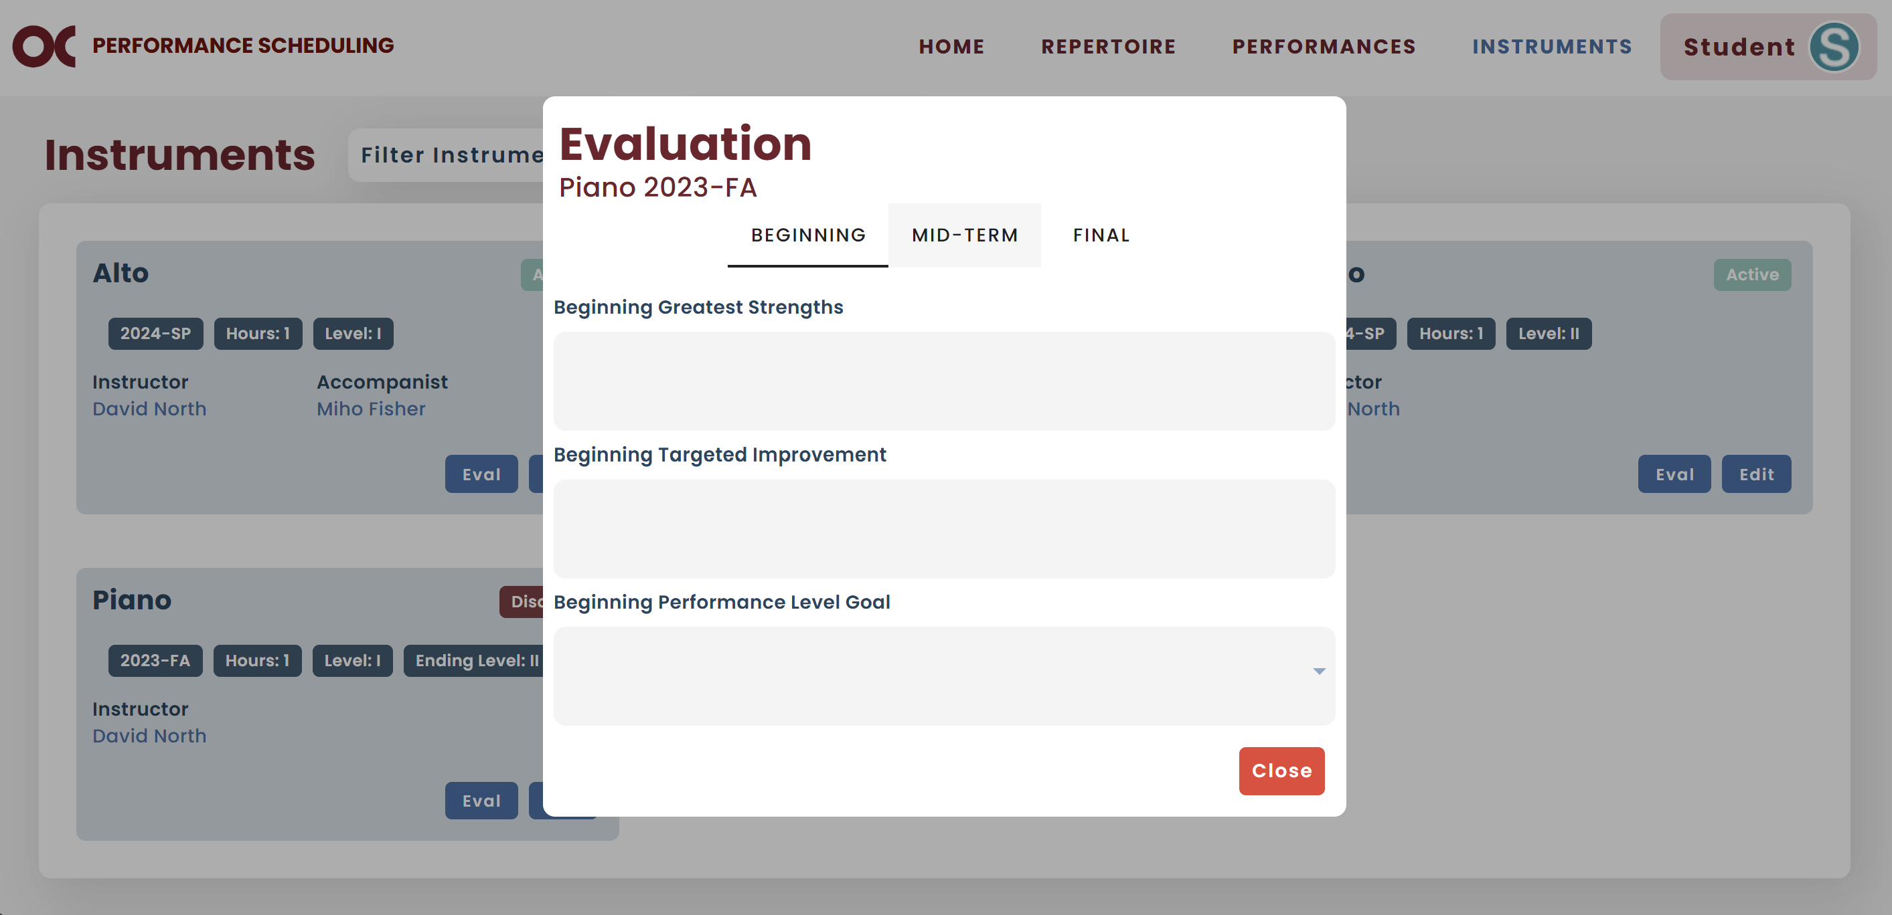

# Repertoire

* You can view all your pieces on your Repertoire screen.

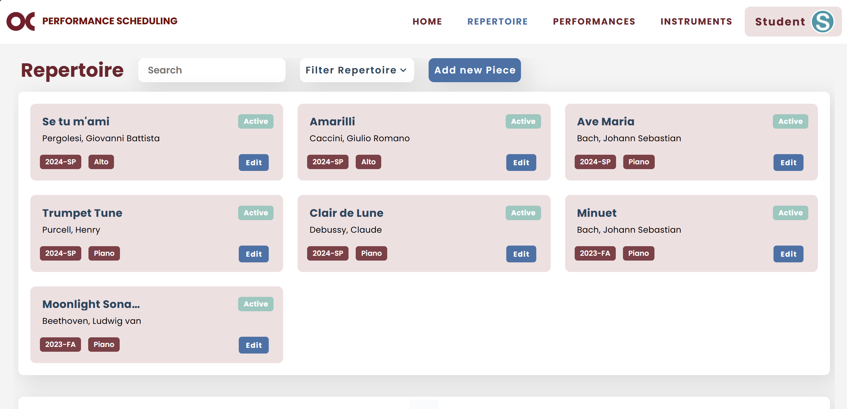

* You can filter them by instrument, status, or semester, or search for a specific one.

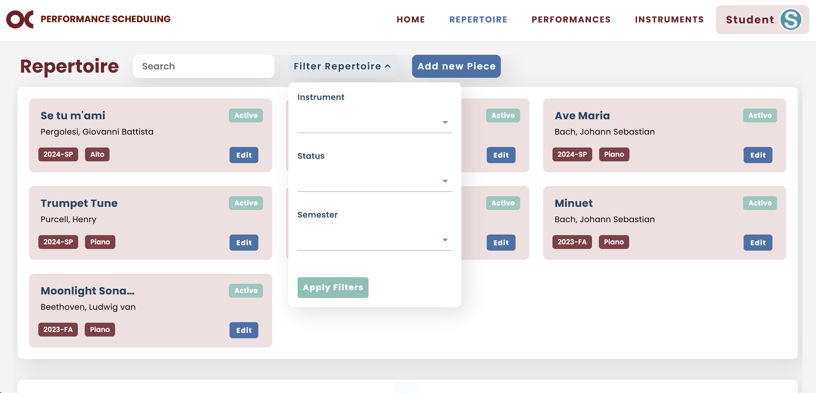

* If you want to add a new piece to your repertoire, click Add new Piece.



* 1. To add a new piece, you first have to select your instrument.
  2. Type the name of the composer.
  3. If you cannot find the composer, click Add Composer.

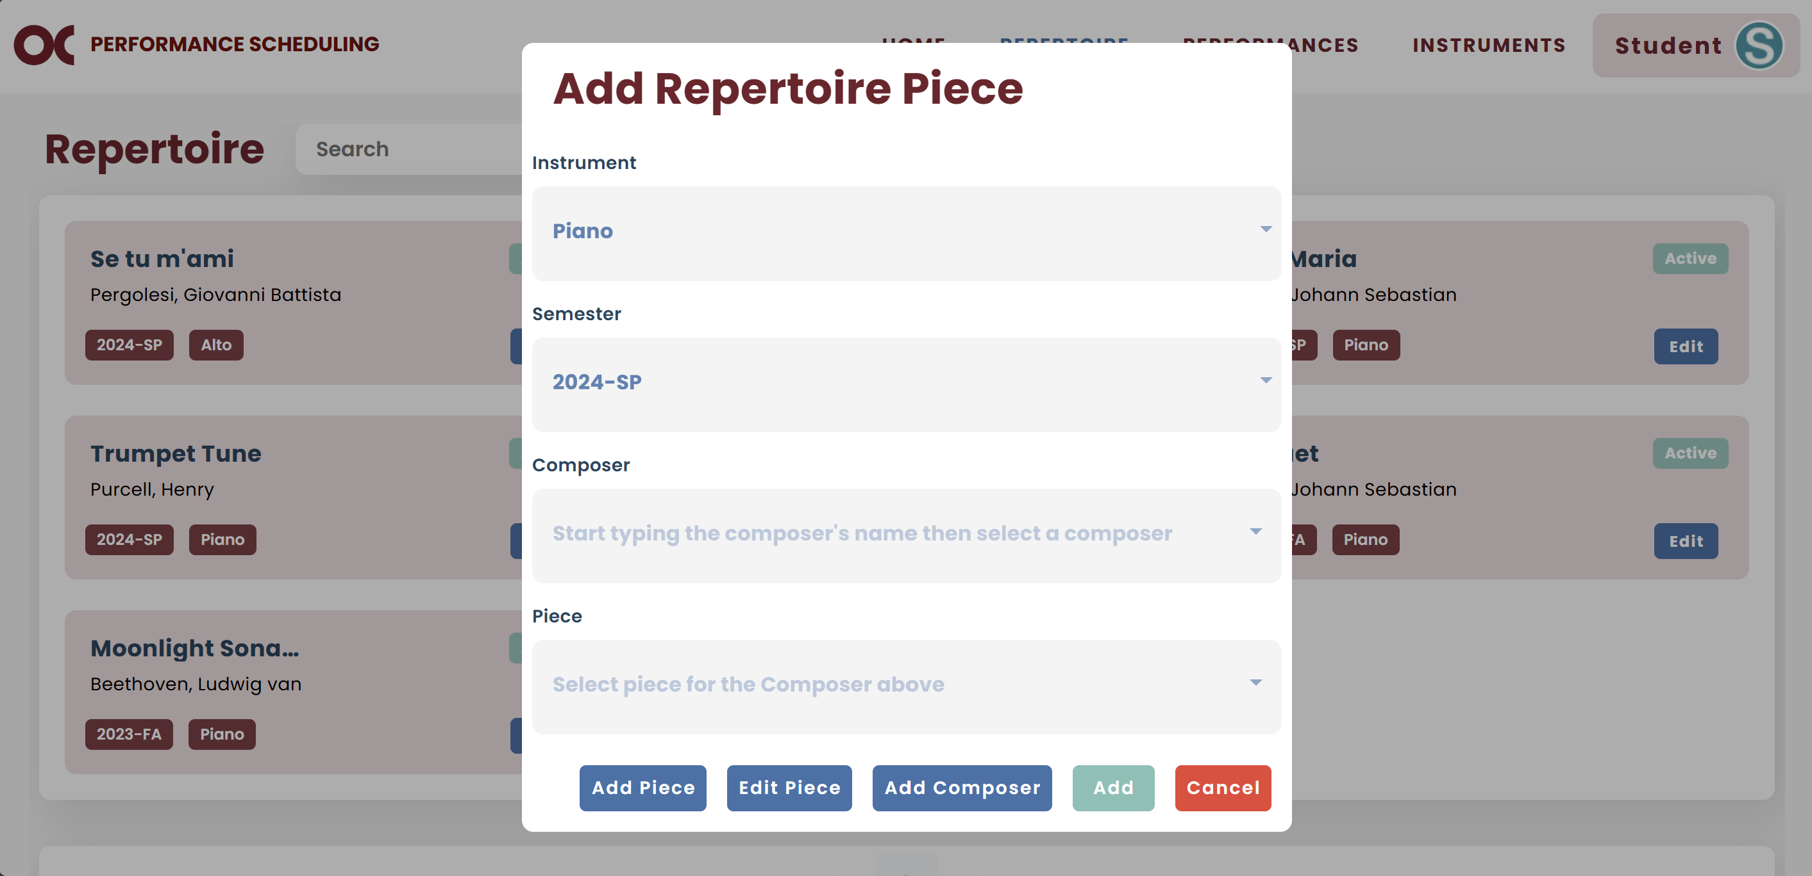

* 1. Type the proper information and click Add.

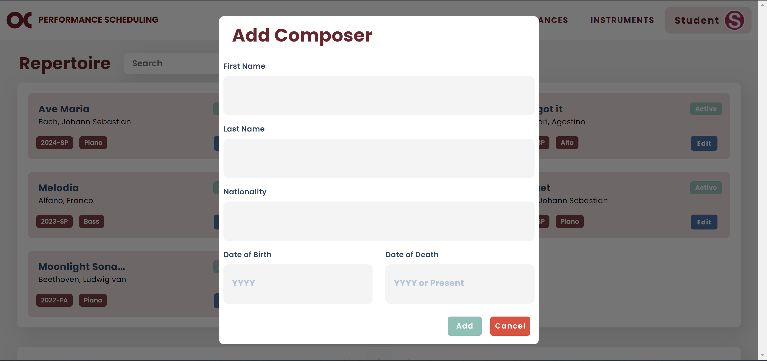

* 1. Now you can type the name of your composer, and it will show in the list.
  2. After selecting your composer, select the piece.
  3. If you cannot find it, click Add Piece.

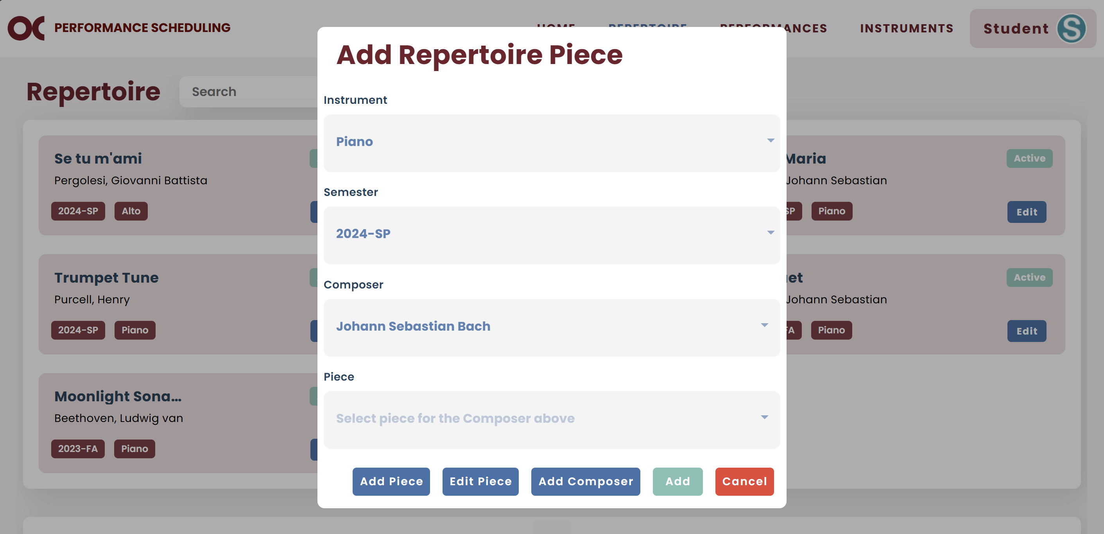

* 1. Type the proper information and click Add.

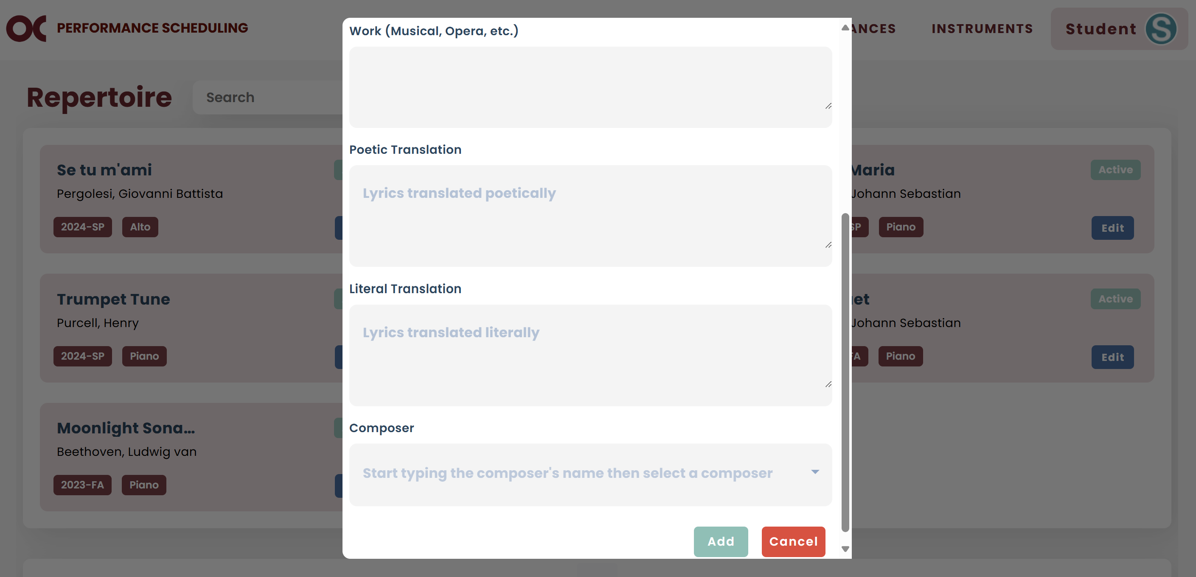

* 1. Now you can type the name of your piece, and it will show in the list. If there are any duplicates, you can select any of them.
  2. If it is a vocal instrument, the poetic and literal translations will be displayed.
  3. If they are empty (displaying the placeholder) or incorrect, click Edit Piece.

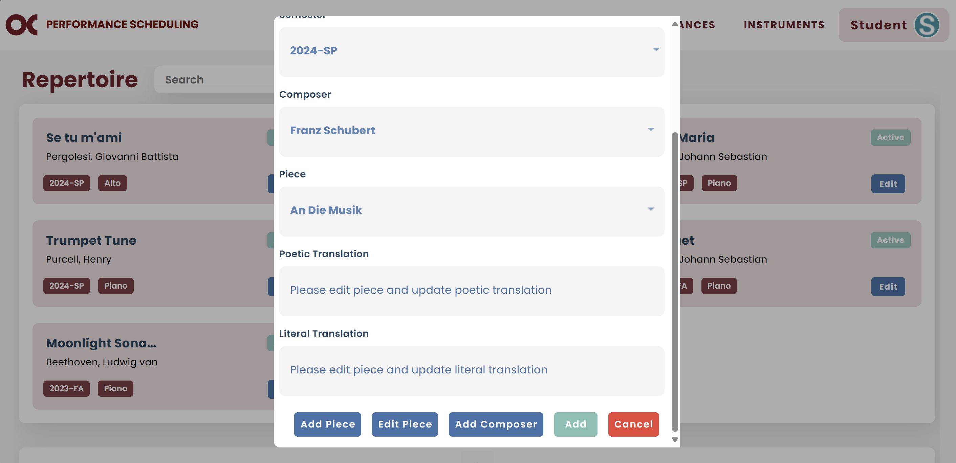

* 1. Enter the information, scroll down, and click Save.

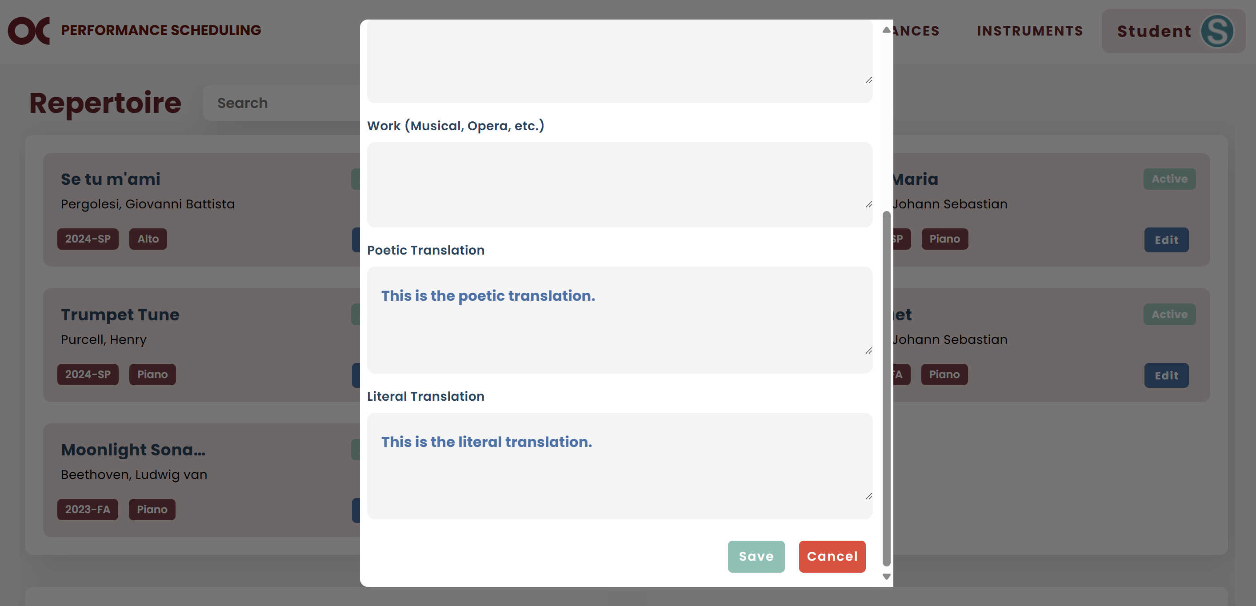

* 1. Now the information is displayed on the main screen.
  2. If all the information is correct, you can click Add to add this piece to your repertoire.

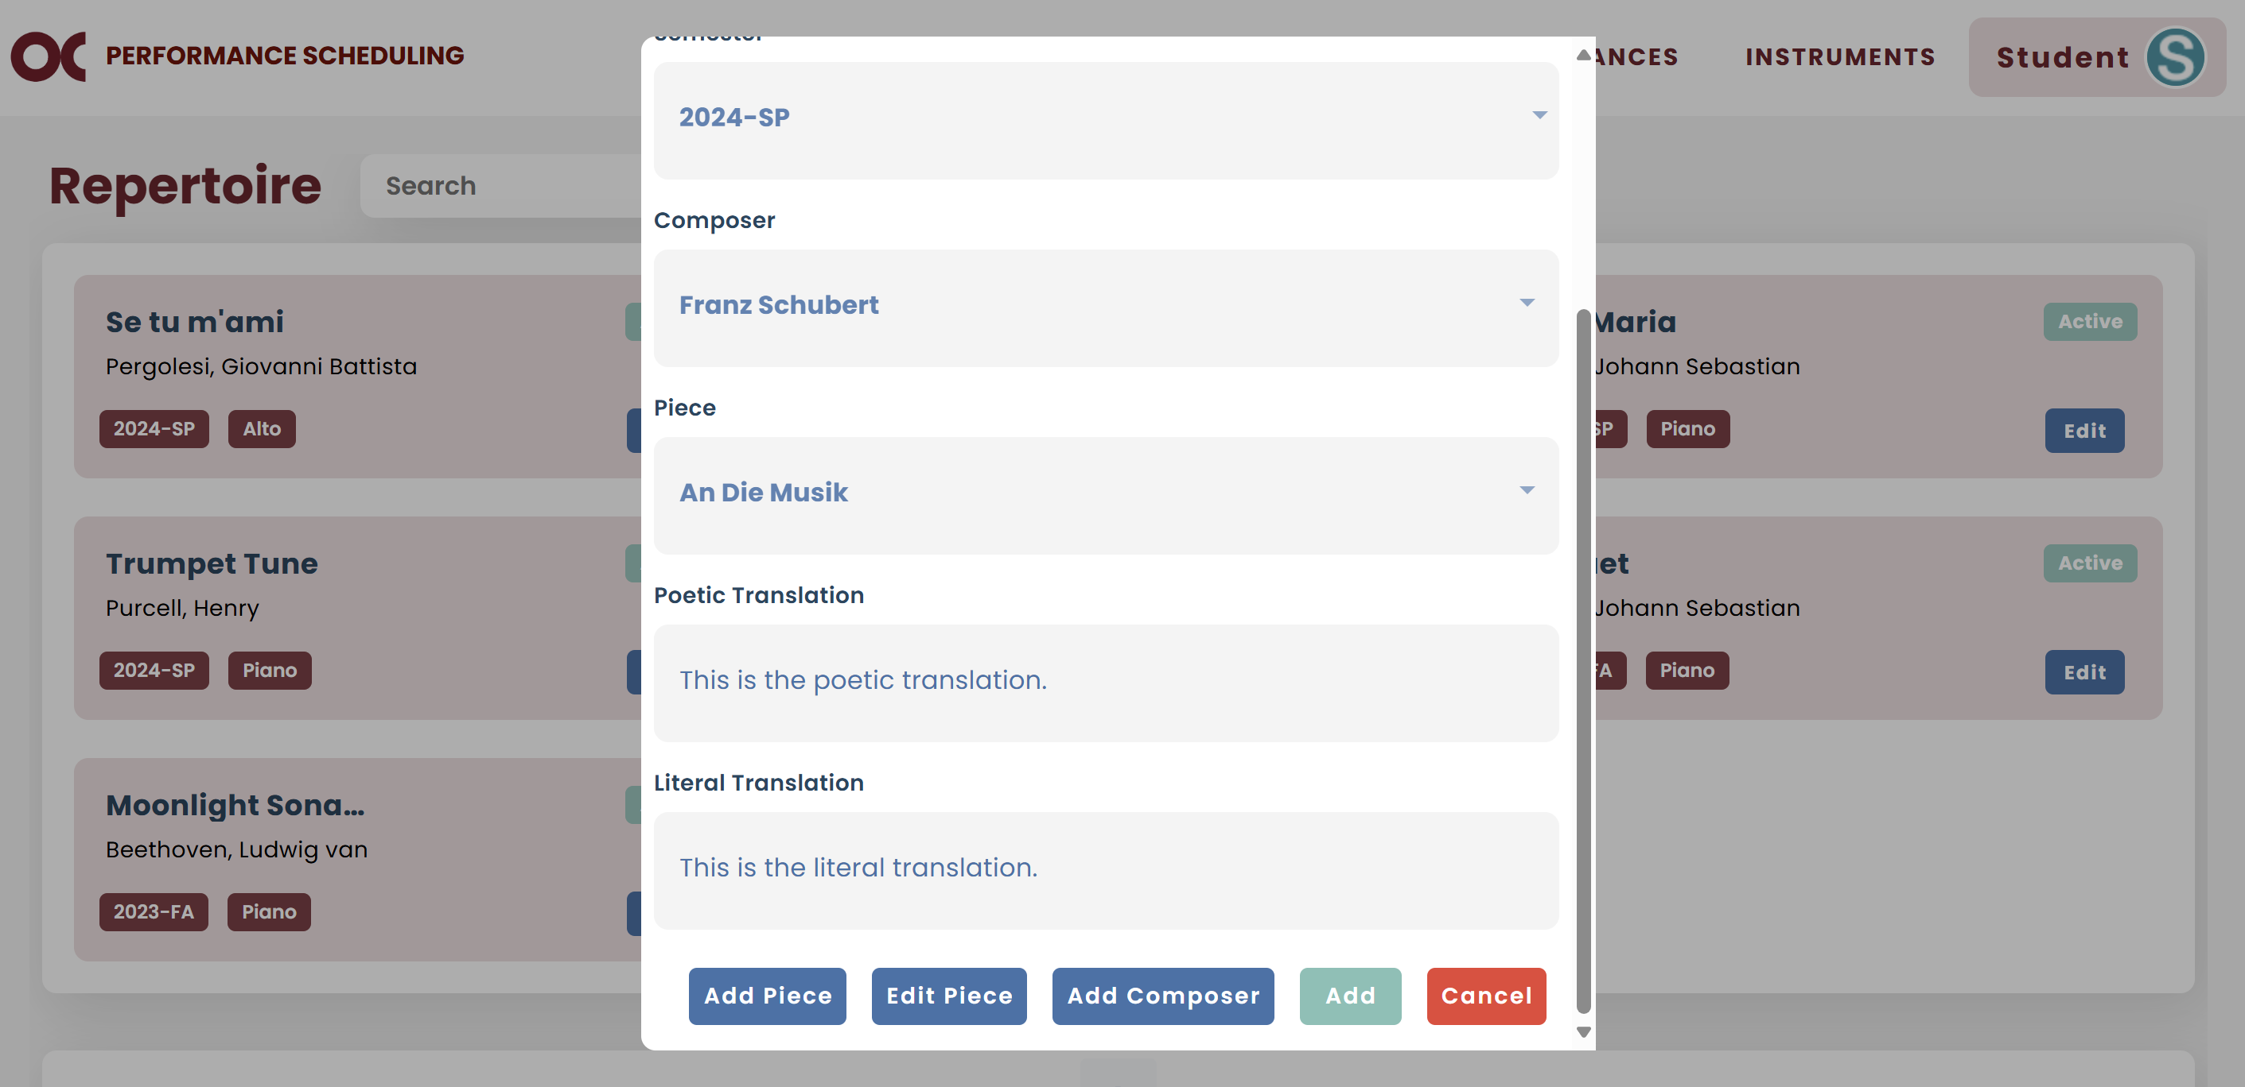

# Logout

* Click on Student and then Logout.

